VOICES FROM THE PAST
1430 BC to 1210 BC
220 YEARS OF DIALOGUE FROM GREEK AND HITTITE KINGS:
THE TRUTH ABOUT HOMER AND THE TROJAN WAR!

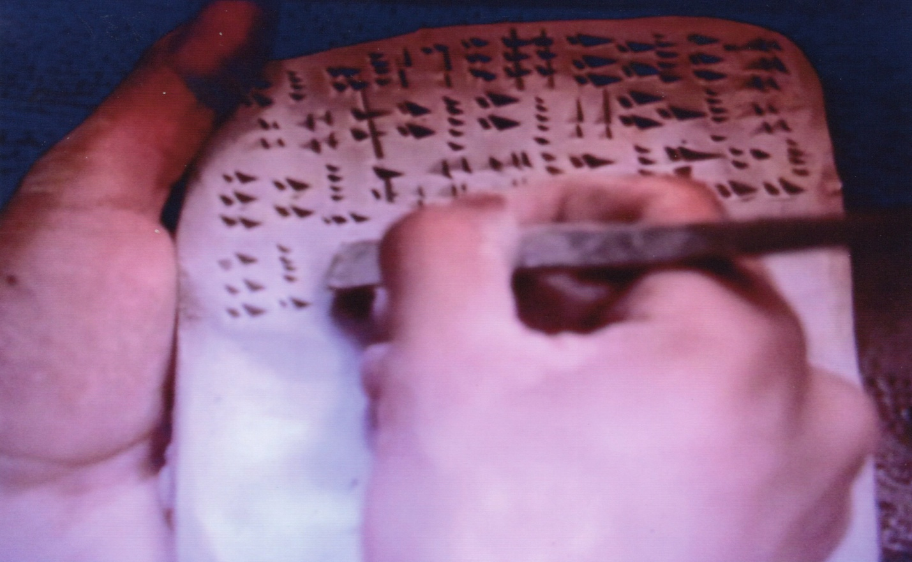

James G. Brianas, Ph.D.
August 2018
Revised April 2020
©2018 and 2020

This research paper has been produced specifically for educational purposes
by “THE ACHILLES FOUNDATION”
a nonprofit 501(c)(3) organization
www. achillesfoundation.org
and may be reproduced for such purposes but not for financial gain.
It is targeted to a general audience.

Appreciation is extended to Dr. Richard Beal of the University of Chicago’s Oriental Institute “Hittite Dictionary Project.” Subsequent to my visit to the Institute’s library and museum spring 2018, Dr. Beal, a Hittitologist with onsite experience at Hattusa the capital of the Hittites, was very informative and peaked my interest which led to this writing. His proof reading of this monograph provided key revisions on the Hittites, their culture, and their kingdom. Appreciation is also extended to Dr. Theo P.J. van den Hout, Chief Editor of the Chicago Hittite Dictionary Project, for providing insight into other discoveries at Hatussa, including fragments of wall paintings, to Babis Intzesiloglou for elucidating the presence of Mycenaean artifacts in central Thessaly, and appreciation to the many individuals, including friends, colleagues, and staff at museums and ancient sites, during my 3 month research trip to Greece plus Turkey summer of 2019, who provided support and insight into the wonder of their ancient past which lead to this 2nd edition and the many photos which have been added. A special thank you to my friend and colleague, George Apostolopoulos, Athens, for his many translations into Greek, this one also. One of the three authors of “The Ahhiyawa Texts”, Trevor Bryce, was also very kind to critique my 2nd edition, spring 2020. His overall comment, “Your paper very effectively analyses and sums up all the evidence to date … (with) well argued conclusions,” was much appreciated.

Front Cover: Photo of Akkadian writing.

Unless otherwise identified, all other photos are those of the author.

TABLE OF CONTENTS

 | Page
Synopsis ____________________________________________________________________ | 5
The Ahhiyawa Texts – Background _______________________________________________ | 7
Early Greek History – The Minoans ______________________________________________ | 8
The Mycenaeans _____________________________________________________________ | 9
The Hittites _________________________________________________________________ | 10
The Ahhiyawa Texts __________________________________________________________ | 11
1430 BC and Reign of 1390 to 1380 BC ____________________________________________ | 12
1318 and 1317 BC – Reign of 1321 to 1295 BC ______________________________________ | 14
1310 BC – Reign of 1321 to 1295 BC ______________________________________________ | 15
1300 BC ____________________________________________________________________ | 16
1295 to 1272 BC _____________________________________________________________ | 17
1267 to 1237 BC _____________________________________________________________ | 17
1237 to 1209 BC – 1 __________________________________________________________ | 23
1237 to 1209 BC – 2 __________________________________________________________ | 24
1205 BC ____________________________________________________________________ | 25
Descriptive and Analytical Summary of the Evidence _______________________________ | 26
Are the Texts the “Smoking Gun?” ______________________________________________ | 31
Collapse of Civilizations of the Late Bronze Age ____________________________________ | 33
Final Word on the Trojan War __________________________________________________ | 41
Addendum __________________________________________________________________ | 45
Cuneiform and Hieroglyphic Tablets ______________________________________________ | 46
The Message, The Messenger, and The Method ____________________________________ | 47
Bibliography _________________________________________________________________ | 48

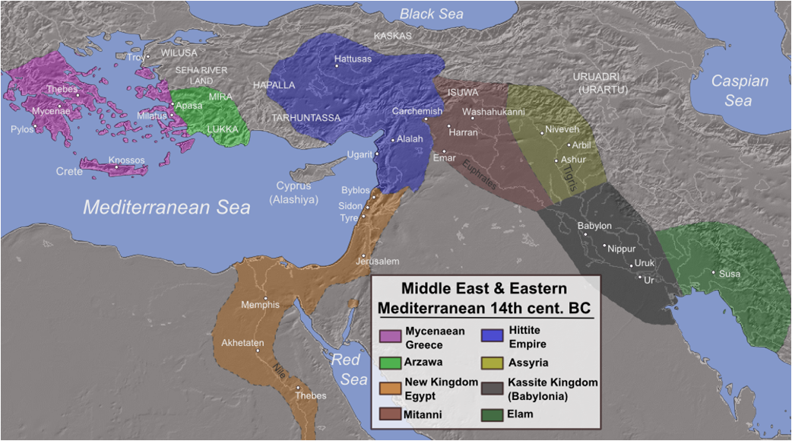

From C. Bryan Rose, University of Pennsylvania, excavator at Troy from 1988 to 2012,
presented to this author from slides November 29, 2017.

Was western Anatolia, lands mainly along the coast and inland from the eastern Aegean Sea, the homeland of the kingdoms of Mycenae, Tiryns, and Argos? As recorded in “The Ahhiyawa Texts”, many wars were fought in that region for some 200 years during the Late Bronze Age. In his presentation on “Achilles in Anatolia” in 1998, archaeologist Eric H. Cline stated:

“… according to the Greeks (Pausanias 11.16.3), by the Late Bronze Age, both Tiryns and Argos had legendary links of some kind to Anatolia. Perhaps most important is the legendary connection of the Atreid dynasty at Mycenae with Anatolia. According to Thucydides (460 to 400 BC) Pelops, father of Atreus (and grandfather of Agamemnon), came to Greece from Asia (a name derived from “Assuwa” lands in the western Anatolia which included Arzawa, Miletus and surrounding region, and the Seha River Land shown on the map above left). … Pindar (Olympian 1.24) also has a reference to “the Lydian Pelops while Pausanias (V.1.7) refers to “Pelops the Lydian, who crossed over from Asia”. …Thus according to the legends of the Ancient Greeks, Mycenae, Tiryns, and Argos all traced at least part of their ancestry back to the coalition of states known as Assuwa”.

Does this legend provide the “birth given right” of the Ahhiyawans (Mycenaean Greeks) to claim and fight for land in Anatolia (Asia Minor)? The answer is beyond this paper, but northwest of Assuwa, and also involved in the many wars of western Anatolia, is the Troad region and the city of Troy, site of Homer’s infamous Trojan War.

SYNOPSIS

For over 2 millennia questions surrounding the dating, content, authorship, as well as the authenticity of the Trojan War have confronted as well as confounded scholars, students of history, and ardent readers. Now as documented by contemporary writings on clay tablets of the Hittite library (‘The Ahhiyawa Texts”) from over 3200 years ago during the Late Bronze Age, we can say with historical accuracy:

- Greek and Hittite kings corresponded with each other for some 200 years.
- During this period there were several wars in western Anatolia (present day Turkey) among the many kings of that region, but most notably between Greeks and Hittites.
- Around 1250 BC a war between the Greeks and Hittites, precipitated by the Hittites, is documented occurring specifically at Troy (Wilusa), the Troad region; i.e. a Trojan War.
- The Hittite kingdom, while not uniformly reaching the eastern Aegean coast, did possess as vassal states many smaller kingdoms in western Anatolia under their authority, kingdoms whose cultures mirror more that of the Aegean than the land locked Hittites.
- During the 200 years, the Greeks attempted to secure territory in western Anatolia waging wars, including at Troy, inciting wars by the smaller kingdoms against the Hittites even as far away as the island of Cyprus, finally being successful, with local support, in capturing and holding territory in southwestern Anatolia at Miletus (Milawata).
- During the waning years of the Late Bronze Age, the Hittites battled the Egyptians to a stalemate at the final battle of Qadesh (1274 BC) in present day Syria ultimately signing a peace treaty in 1259 BC, but subsequently losing wars with the Assyrians in their far southeastern borders which greatly weakened their position there (1237 to 1209 BC) as well as in far western Anatolia along the Aegean coast when the Greeks and Hittites were feuding and communication between them came to an end.

This leads to the conclusion that with the Hittite kingdom weakened, the Greeks had the opportunity to execute their long held desire of some 200 years to finally secure Troy as their own. Along with the many wars in the Troad and western Anatolia, the final war by the Greeks against the Trojans very likely occurred during this period, 1237 to 1209 BC.

This then leads to the question, was this apparent war Homer’s Trojan War? Many would no doubt like for the sake of closure on this over two millennia quandary to say yes. Homer was likely born in Smyrna 800 BC on the eastern Aegean coast and later lived on the island of Chios, regions in the midst of the above wars. Believing him to be the author of the ILIAD and ODYSSEY, he (1) did not have access to Greek historical documents since in the Late Bronze Age the Greek alphabet was yet to be invented. (2) Homer may have had access to Luwian, Phrygian and possibly Phoenician writings/script, lost through time, which may have provided insight into the wars of that region. (3) Like Strabo and Pausanias centuries later, he very likely traveled, before blinded, to Troy, Greece, and the Greek islands recording and documenting stories (the Greek alphabet had finally been invented) from the very people who lived in these lands, many descendants of those Trojan War fighters, stories handed down from generation to generation. (4) He clearly saw and identified the architectural remains, the walls and fortresses, some abandoned. From this, Homer ingeniously composed one major war, the “Trojan War.”

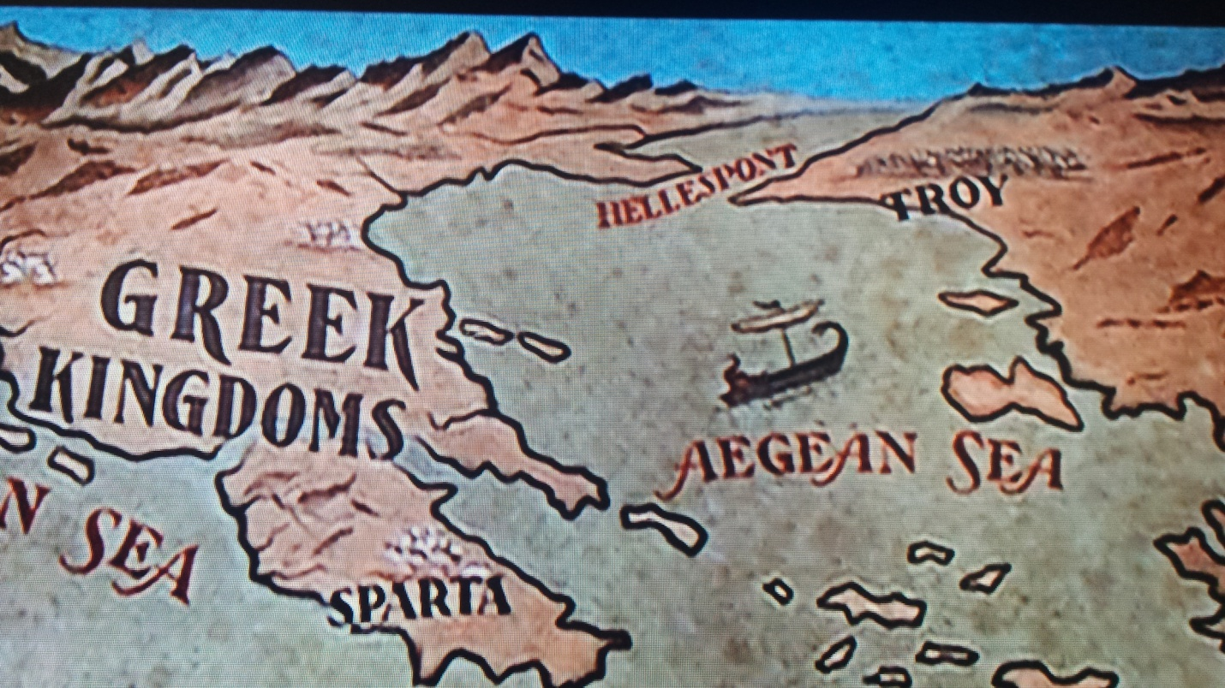

A map characterizing the geography of Homer’s war between the Greeks and the Trojans.
From Hollywood cinema “Helen of Troy” 1956.

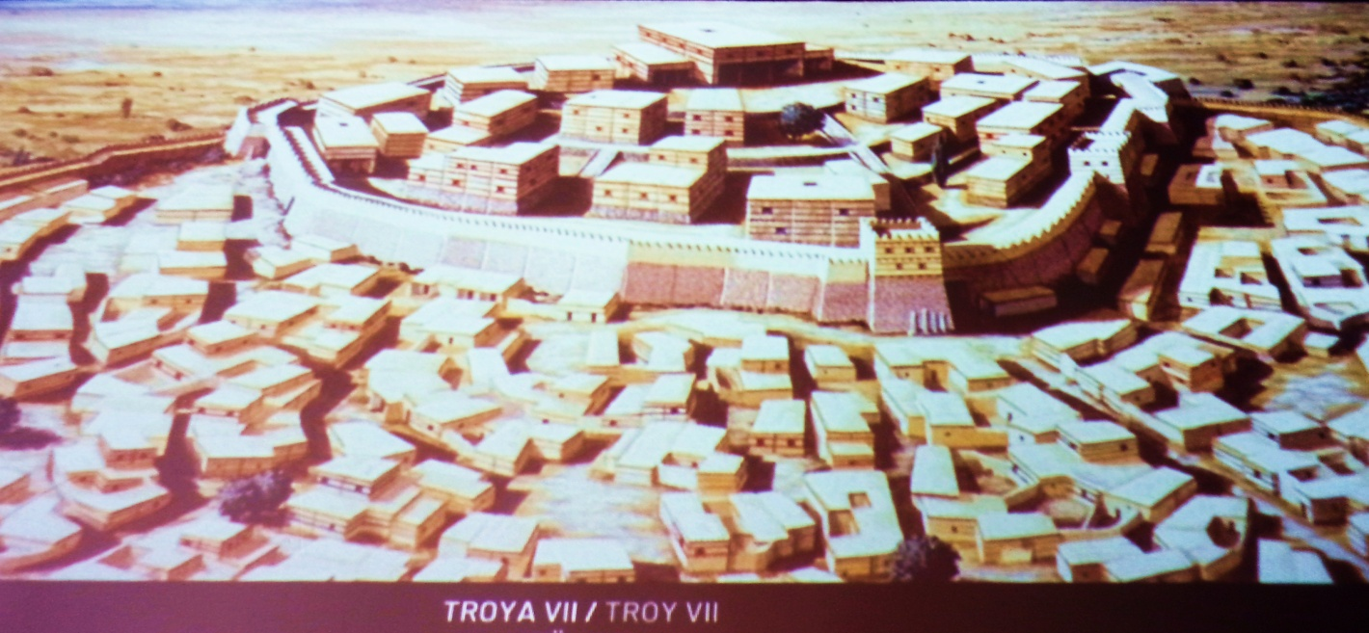

Reconstruction of Troy, a city of 10,000, which the Greeks for 200 years attempted to capture.
From the archives of the Archaeological Museum of Troy, September 2, 2019.

VOICES FROM THE PAST
James G. Brianas, Ph.D.
Abstract
“The Ahhiyawa Texts” provide a window into the past – written evidence and dialogue from and between the kings of two great powers of the Late Bronze Age, the Mycenaean Greeks (Ahhiyawans) and the Hittites of central Anatolia (Asia Minor, present day Turkey). Warfare, hostilities, intrigue, and occasional periods of peace underlie the tensions revealed during the 220 years covered by these texts. It is a mirror into “The Human Side of Archaeology,” with human concerns, feelings, questions, anger, doubts, greed, religious fervor, and family dynamics of those in power, very likely similar to what we are experiencing in the world today. It provides a message to both believers of Homer and the Trojan War as well as to the doubters.

The Ahhiyawa Texts - Background

Ever since the discovery of the “Hittite Library” by German archaeologist Hugo Winkler in 1906 which by 1912 consisted of some 10,000 clay tablets in what is now central Turkey (ancient Anatolia and Asia Minor), debate has continued on the questions surrounding Homer’s Trojan War and the Mycenaean Greek and Hittite involvement in their own conflicts in western Anatolia documented through correspondence from and between the then known “Great Kings” of Anatolia and the Aegean region. Within that “Library” were nearly 30 texts (letters) relating to “Ahhiyawa” whom most scholars believe to be the Late Bronze Age Mycenaean Greeks, identified by Homer as Achaeans, from Achaia. The Ahhiyawans may have been a coalition of the many kingdoms (29 identified by Homer) that existed on mainland Greece and on the Aegean islands. And for Homer’s Iliad, his “Catalogue of Ships” from these kingdoms (palatial city-states) “is regarded by scholars as an authentic piece reflecting Bronze Age realities” (Beckman, Bryce, and Cline, 2011, plus Rose, 2014, Visser, 1997, Latacz, 2004, etc.). This author’s 20 years of archaeological research in Greece, the islands, as well as Turkey, further attests to this. For example, Homer’s description of palace sites of the Greek kings could only have come from his travels throughout the Aegean and mainland Greece to include his reference to “Sandy Pylos,” home of King Nestor, on the southwest coast of Greece, or Mycenae’s “Huge walled citadel” of King Agamemnon south of Corinth, or “Rugged Trachis,” a jagged mountain complex near the Sperchios River at Lamia whose warriors fought under Achilles at Troy, or “Rocky Ithomi terraced high,” with a huge stone façade, in western Thessaly in the kingdom of Machaon and Podalirus, sons of Asclepius, who were doctors at Troy. Visits to these sites today show that they are exactly as described by Homer, the first two which are well-known. (Further in this monograph, more detailed descriptions of Homer’s “Catalogue of Ships” and the Greek kingdoms identified will be presented with particular focus on this author’s expertise, that of the region of ancient Thessaly, homeland of Achilles.) And maybe to the bewilderment of many, according to Paul Bahn in his edited Illustrated History of Archaeology, 1996, Homer is “often considered the father of archaeology. It was Homer who was instrumental in turning people’s eyes to the past through his descriptions of the Trojan War in the Iliad, and peoples from different lands in the Odyssey.” But for Latacz, 2004, the Trojan War is “not a tale of Troy but the tale of Achilles,” for the Iliad does not cover the ten years of the war but the last 51 days, and its focus is Achilles. This author agrees though the war itself is the defining centerpiece.

The question remains, do these Ahhiyawa texts vindicate Homer in any way? This was a man, likely born in western Anatolia in the eastern Aegean, well traveled and who like a singing minstrel, a bard, would for hours perform at the court of possibly feasting, ruling royalty singing to the tune of a lyre and reciting stories of old, the glorious past of Greece, no doubt very entertaining to his audience. To the ancient Greeks, Romans, and later Byzantine Greeks the Trojan War was real. Let these “Voices from the Past,” some of the earliest dialogues in recorded history, come to life as they speak directly to you – 220 years reflecting “The Human Side of Archaeology” - putting a human face to words spoken and transcribed over 3200 years ago. To provide a more comprehensive understanding and better assess the historical significance of this dialogue, supporting historical and narrative information for the period in time prior to the texts, during the 220 years of the texts, as well as the period after the texts will be briefly presented. Included will be an analysis of the dialogue plus the supporting information, prospective scenarios derived from this, and the author’s own data-driven conclusions, the later more in line with investigative journalism, traditional detective work, to augment the archaeological and historical framework of this monograph. On the texts themselves, particular attention should be paid to the following:

- Above all, the actual spoken words and acts of the kings as transcribed by their scribes.
- The supporting historical and narrative data provided concurrent with this time frame.
- The leadership and management styles and behavioral characteristics exhibited by those in power (any different than many people in positions of power, today included?).
- The role that religion plays on the behavior of the Hittite rulers (humans through the ages appear to have an innate need to worship or rely on some higher being or beings.)

Early Greek History – The Minoans

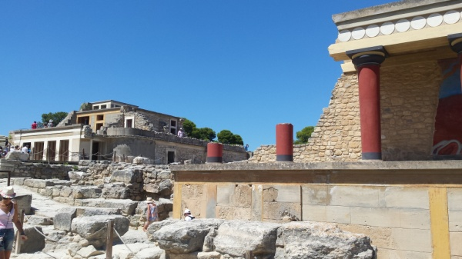
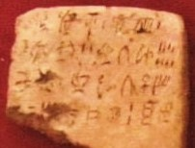
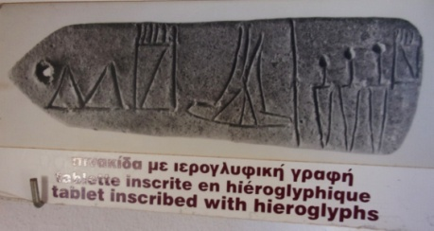
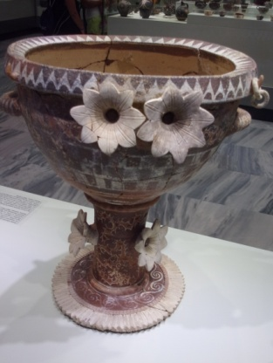
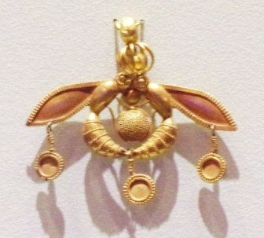
“Still, the reconstruction of the earliest Greek history remains the most important task of modern historical science.” So stated noted German archaeologist Wolf-Dietrich Niemeier, echoing the words of Furumark at a conference on “The Minoans,” January 2005 in Athens, Greece. This comment foreshadows the fact that the identification of the first Greeks, the first cohesive Greek culture, is still in the state of becoming. For the purposes of this writing it is the Minoans, centered in Crete, who take that honor although records show that people from the Levant (Canaanites from Phoenicia, great sea traders) traded with and greatly influenced the Minoans (Holst 2011, Quinn 2018). Holst in particular, who taught in modern Turkey and visited many ancient Phoenician settlements in the Mediterranean, stated (p. 105), “In this way the Minoan Empire was born. The local people of Crete, and the Phoenicians who arrived by ship, merged into a new society that had not existed before. Many elements were drawn from the old Cretan society, but the majority of its principles came from the Phoenicians.” From their evolution in the pre-palatial Early Bronze Age beginning in 2900 BC to the middle of the Late Bronze Age of 1450 BC and beyond, the Minoans gradually exerted their influence spreading their culture and their products throughout the Aegean, the eastern and southern coasts of the Greek mainland as well as western Anatolia with trade routes to Egypt, Cyprus, and the Levant, the Syro-Palestine coast. Their palace complexes were often large two and three story structures with typically colorful columns, interiors adorned with beautiful frescoes, a large courtyard, and no fortification walls. (See photo from Knossos as seen today.) Their dialect, identified on Linear A tablets found at several sites on Crete, has yet to be deciphered. Enclosed is a tablet from Zakros, eastern coastline of Crete, housed at the Archaeological Museum of Sitia. Prior to Linear A the Minoans used hieroglyphs, also not deciphered, as shown on a tablet from Malia, NE coast of Crete. The Aegean region and the entire eastern Mediterranean by the Mid and Late Bronze Age, 1750 to 1200 BC became very cosmopolitan with palatial elites trading among themselves – perfume and other luxury goods, precious metals for jewelry and weapons, wine, oil lamps, and food products. This included the major kingdoms of the Minoans, the Hittites, the Egyptians, Assyrians, and the Babylonians. These luxuries included items like the finely engraved gold bee pendant from the necropolis at Malia, copied even today and sold in many jewelry stores, and the exquisite Kamares vessel for banqueting ceremonies from the palace of Phaistos on Crete’s southern coast, both dated to about 1750 BC and housed at the Archaeological Museum of Heraklion.

The Mycenaeans
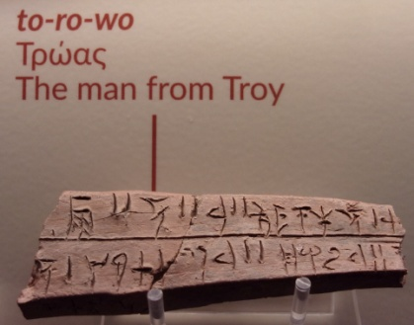
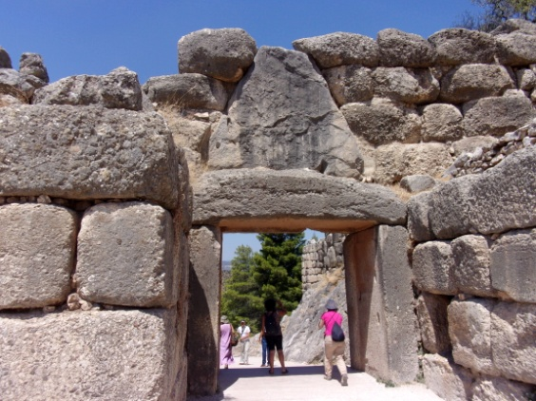
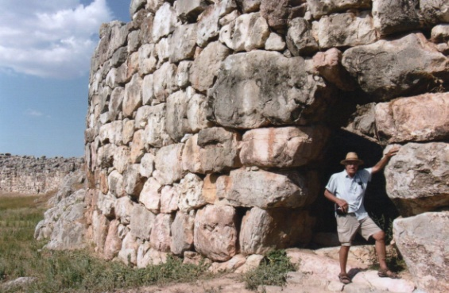
But a force of nature ended the dominance of the Minoans. The volcanic eruption on the island of Thera (Santorini) in the Aegean Sea north of Crete probably in 1628 BC (originally believed to be 1450 BC and later 1540 BC) gradually brought the demise of the Minoans. By the mid 15th century BC it was the mainland Greeks, the Mycenaeans, who filled the void taking over many of the palaces on Crete and the colonies, settlements, and trade routes of the Minoans though Knossos, capital of the Minoans and five miles inland from Crete’s mid northern coast, appeared to have survived until the mid 14th century BC. Linear B tablets of the Mycenaeans, using a script derived from Linear A and finally deciphered in 1953 by architect Michael Ventris, have been found on Crete at two sites only, Chania (ancient Kydonia) and Heraklion (Knossos) but throughout many mainland Greek sites. Its primary use was for inventory and identification purposes. (See photo of Linear B from the Archaeological Museum of Thebes.) While the Minoans were considered more peaceful, the Mycenaeans reflected a more militaristic and warlike character as they evolved from about 1650 BC, many building fortified fortresses with massive cyclopean walls with palace centers (megarons), also adorned with colorful frescoes, whose ruling elites promoted a centralized, top-down administration and a highly stratified social structure within their city-states. (See photo exiting the lion gate at Mycenae’s western wall plus the sally port and southeastern fortress wall of the citadel at Tiyrns.) Homer’s Iliad portrays a good example of their militaristic and hierarchal culture including the coalition of 29 kingdoms with their kings and commanders pulled together, however tenuous, to fight the Trojans and their allies in the Troad (Troy) of northwestern Anatolia. It is a story that has captured the imagination and certainly the professional efforts of scholars and students alike for many generations. Is the Iliad myth, a legendary story of some glorious past, or is it real, does it reflect historical reality? Actual written dialogue from and between Greek and Hittite kings and other officials provide a picture of that mysterious and elusive past.

The Hittites

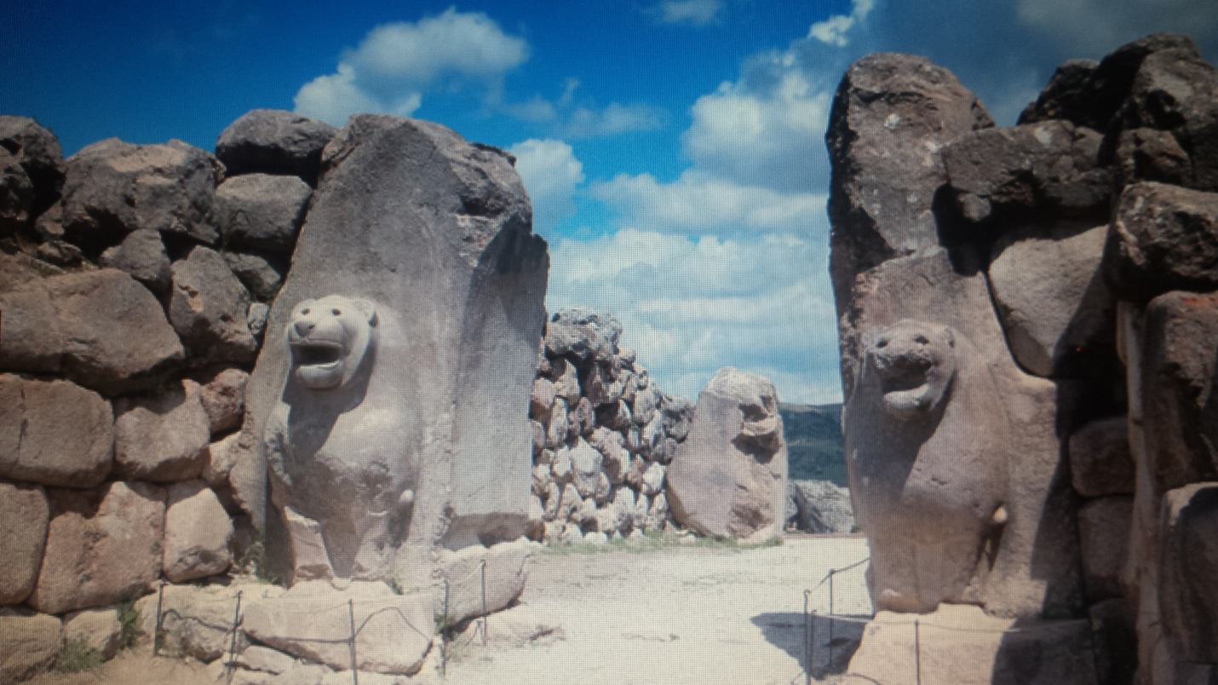
But who were the Hittites? Their kingdom evolved from an Indo-European group moving into central Anatolia (modern Turkey) around 1650 BC, similar timeframe to the emergence of the Mycenaeans in Greece. Both migrations, to Greece and Anatolia, likely originated from the Danube Valley to the north in Central Europe, following the route of earlier migrations to warmer climates during the early Bronze Age beginning around 3000 BC. The Hittites may also have forged south from the Caucasus. But while the Mycenaeans were unified by culture and language they remained fragmented into several kingdoms. The Hittites on the other hand, who originally captured the land from the Hatti people, eventually united their separate groups under the force of a strong leader. Their capital city was Hattusa, modern Bogazkoy, 120 miles east of modern Ankara. From there their kingdom reached its zenith during the 15th and 14th centuries BC extending their empire south and southeast to the modern Syrian coast and northern Iraq (Mesopotamia) as well as to the far west reaching part of the western Aegean coast including Troy. Lion gate (photo from the Oriental Institute Museum, Univ. of Chicago) shows the view from the south end of the fortress at Hattusa well fortified like that of the Mycenaeans. Artistic renderings of fragments of wall paintings have been found plus a six foot stone carved sphinx. Their western territories were primarily vassal states, smaller tributary kingdoms to the Hittite crown. The Hittites were on a virtual constant war footing with the Mycenaeans to their far west and the belligerent Kaska people to their north and somewhat the same with their vassal states, plus to their south and southeast the Egyptians and Assyrians, all this interrupted by occasional periods of peace. They developed writing, a cuneiform script likely borrowed from Assyrian speakers. (See tablet from the Archaeological Museum of Istanbul.) From this their scribes, who maintained their bureaucracy, would write on clay tablets words spoken by their king or other court officials, for correspondence and record keeping, including important events or acts that occurred, providing a library which has survived to this day.
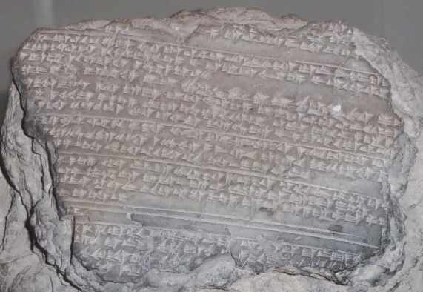
The Ahhiyawa Texts

Many of the texts (letters), written on clay tablets in cuneiform, the official script of the Hittites used for diplomatic and administrative purposes, are very lengthy, reflecting complete thoughts, others are incomplete due to missing tablets or words or words that are unintelligible with precise dates of the letters often unclear. Akkadian, the “lingua franca” for international correspondence, was also used. Small and irregular, the tablets were usually 3X4 inches in size (7.5X10 cm). The Ahhiyawa Texts, by Gary Beckman, Trevor Bryce, and Eric Cline, Society of Biblical Literature, 2011, has been the source book used in discussing the writing on these tablets. This outstanding piece of literature presents the texts (26 of them, though not in chronological order) with transliterations showing English phonetics on the left and translations on the right, to include commentaries and essays on the whole Ahhiyawa question. This is the first time an English translation of the deciphered texts has been provided in a single volume. It has been an invaluable source to this author as have supporting publications as well as visits with Hittitologists at the Oriental Institute, University of Chicago. The texts, eight of which are in part herein presented and discussed in chronological order, begin with the first referring back to a period of around 1430 BC. To facilitate their understanding, this author has used the missing words or phrases as inserted by the book’s authors. It is hoped that this rendering of the texts targeted to a general audience, though a brief summary, presents an honest and forthright picture as intended by the translators and original authors of over 3200 years ago.

For a glimpse of what is to come, the following dialogue is presented:
Around 1285 BC a king from Ahhiyawa (Greece) writes to King Muwattalli II of Hatti (currently in central Turkey) “Thus says (I) Great King of Ahhiyawa (Greece) – Kagamuna my great-grandfather – married (a princess of Anatolia and received as part of a dowry) -- (so) the islands formerly indeed belonged to the King of Ahhiyawa.” The Greek king is saying that certain islands belong to him because they were given to his great-grandfather, Kagamuna, years ago likely around 1435 BC. (King Kagamuna’s name sounds remarkably like that of the Greek king (K)Agamemnon!) The islands claimed were likely Lesbos and Chios and maybe others such as Lemnos and Imbros. Around 1250 BC King Hattusili III of Hatti writes to the king of Ahhiyawa (Greece), “Concerning the matter (of Wilusa/Troy) about which we were hostile – we have made peace.” The Greek king says, “You have used force against me.” The Hittite king from Hatti replies, “But I was still young.” This dialogue, though occurring several days apart due to the distance traveled between kingdoms in presenting each clay tablet, discusses the war specifically at Troy between the Greeks and the Hittites (from Hatti) of which the Trojans were their allies. This is clear evidence of a Trojan War in which the Greeks participated.

This is but a glimpse of the actual words spoken between kings of two great powers in the Late Bronze Age, over 3200 years ago. It is rewriting our understanding of history from that period.
Let us go back to the beginning when the Ahhiyawa texts first began, a period referring back the late 15th century BC when there were earlier wars close to Troy mentioned above.

1430 BC and Reign of 1390 to 1380 BC
Indictment of Madduwata

Written by scribes in the early 14th century BC for King Armuwanda I (A – author’s abbreviation) who ruled the Hittite kingdom from about 1390 to 1380 BC, many events narrated had taken place under the preceding king, Tudhaliya l/ll (T), in the late 15th century BC, events most probably around 1430 BC. The letter is written to a ruler, King Madduwata (M) in northwestern Anatolia (the Troad region, Troy, is located in that general vicinity and likely a bit north), territory apparently under the authority of the Hittites. King Armuwanda chastises the ruler and wants him to change his manner of ruling which has been a problem to the Hittites. It describes how in 1430 BC King Tudhaliya (T), father of the present king, rescued M from an attack from Attarissiya (possibly the legendary Mycenaean King Atreus, father of King Agamemnon), from Ahhiyawa (as Greece was identified by the Hittite kings). T repulsed the Mycenaean Greeks and after rescuing M assigned him to rule territory in western Anatolia just east of Lazpa (island of Lesbos), requiring him to swear an oath of vassalage (allegiance) to T. M then attempted to expand his territory into Arzawa to the south but failed necessitating T to again come to his rescue. Attarissiya (Atreus) threatened M a second time necessitating T’s intervention again. M continued to engage in intrigues even with his former Arzawa foe (Kupanta-Karunta) seizing Hittite towns and inciting Hittite vassals to rebel against the Hittite king of which some twenty-two vassal kingdoms did. King T successfully repulsed not only the two Greek invasions but also all the kingdoms who had rebelled. All this occurred prior to the reign of the present king, King A. The text concludes with an account of a mission of A’s envoy, Mulliyara, to M. A summary of the actual letter, emphasizing the parts that primarily relate to the Ahhiyawans, follows.

Part 1 – 1430 BC. NW Anatolia. “Attarissiya (Atreus), the ruler of Ahhiya (Ahhiyawa), chased you, Mudduwatta, out of your land. Then he harassed you and kept chasing you. And he continued to seek an evil death for you, M. He would have killed you, but you M fled to the father of My Majesty (King T), and the father of My Majesty saved you from death. He got rid of Attarissiya for you. Otherwise Attarissiya would not have left you alone, but would have killed you.”

Part 12 – 1430 BC. “Attarissiya, the ruler of Ahhiya, came and was plotting to kill you, M. But when the father of My Majesty heard, he dispatched Kisnapili (a commander), infantry, and chariotry in battle against Attarissiya. And you, M, again did not resist Attarissiya, but yielded before him -- 100 chariots and – (several?) thousand infantry of Attarissiya drew up for battle. And they fought.—Then Attarissiya turned away – and he went off to his own land.”

Part 31 – 1390 to 1380 BC. Alasiya, island of Cyprus, much further south and east of the above territory: “Because the land of Alasiya belongs to My Majesty, and the people of Alasiya pay me tribute, why have you continually raided it?” M responds: “But the father of His Majesty never informed me nor had His Majesty ever informed me, thus: The land of Alasiya is mine – recognize it as such.” A responds: “You M are a servant of My Majesty – why have you joined up with them (the Greeks)?”
It is clear, Greek ambitions for territory in Anatolia across the Aegean Sea and elsewhere in the Mediterranean were very strong. Reflecting on the two hostile incursions against M in northwest Anatolia: Attarissiya (Atreus) had 100 chariots and several thousand infantry. It was no small army. King T of the Hittites fought against the Greeks with very likely a larger fighting force effectively repulsing the incursions of the Greeks. In fact, T had destroyed a coalition of twenty-two countries in western Anatolia, commonly referred to by scholars as the “Assuwan Confederacy.” No doubt Hittite control over the territory, a very distant 450 miles (750 kilometers) from the Hittite capital of Hattusa, located on a large rolling plateau then down two valleys surrounding by mountainous terrain leading to the Aegean, was very tenuous. Vassal states took advantage of this and even joined the Greeks, enemy of the Hittites, for mutual gain to not only gain territory but also its resources. But they were unsuccessful.

To further commemorate these victories, T had a sword inscribed about them. Discovered at Hattusa in 1991, it is said to be of Mycenaean Greek design. The inscription reads: “As Tudhaliya the Great King shattered the Assuwan country, he dedicated these swords to the Storm-God, his lord.” (The Storm-God is one of the many Hittite gods, this one similar to Zeus.)

Note: Though not identified in “The Ahhiyawa Texts,” during the reign of Suppiluliuma I, 1350 to 1322 BC, following the one above, the king apparently in 1350 BC usurped the throne from his older brother who was murdered. He subsequently married a Babylonian princess and banished his previous wife to Ahhiyawa territory. He was a warring king (as shown by the “Deeds of Suppiluliuma,” written on several tablets discovered at Hattusa) extending the Hittite empire down into Syria where he eventually got into conflict with the Egyptian Pharaoh Akhenaten, 1353 to 1334 BC. In 1322 BC he died from a plague brought to Hatti (land of the Hittites) a few years earlier by Egyptian prisoners of war. Mursili II, discussed next, recorded the death and plague on tablets known as the “Plague Prayers.”

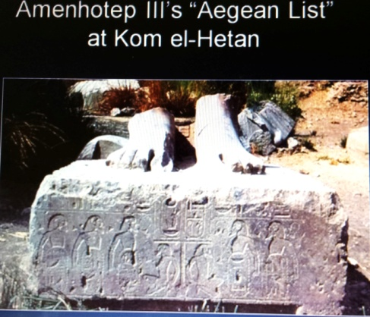
Another note of interest is the “Aegean List.” This refers to a “tour” by the Egyptians (during the reign of Pharaoh Amenhotep III, 1391 to 1353 BC) to the Greek islands and mainland likely around 1370 BC, some twenty years prior to the final destruction of Knossos, capital city of the Minoans, in 1350 BC. The Minoans were for many centuries very influential throughout the eastern Mediterranean including Egypt. Very likely as a diplomatic mission, the Egyptians went to cement relations with an old trading partner, the Minoans, whom they visited first on Crete (the Egyptians called Keftiu) then traveled to mainland Greece (they called Tanaja) visiting the island Kythera in the southeast then to Mycenae and its port city of Nauplion, and on to the region of Messinia (Pylos) and possibly Thebes in Boeotia and returning through Crete. This “list” was inscribed on a statue base the remains found at a necropolis across the Nile from the city of Thebes, modern Luxor (photo from Eric Cline, George Washington. Univ.). The mission was also taken to meet with the Mycenaeans, “new on the trading block.” During this period, the Hittites were expanding their power base no doubt disconcerting to the Egyptians. The diplomatic mission may also have involved securing Greek support, possibly as allies, or at the least encouraging the Greeks to continue their incursions into western Anatolia to maintain Hittite focus away from their southern border with Egypt.

A further interesting side note to the Hittite king is his receipt of a request from an Egyptian queen stating, “My husband is dead. I have no son. – If you would give me one of your sons, he would become my husband. --” This is the message discussed by King Suppluliuma in the cuneiform tablet shown in the brief introduction to the Hittites earlier in this monograph. Such a request was unheard of in Egyptian annals whose royalty typically did not marry foreigners. After much questioning of the request, the king did send his fourth son who was subsequently ambushed en route to Egypt. The queen was either Nefertiti, 1353 to 1334 BC, or more likely, Ankheserpunten, the wife of the boy king, Tut, 1336 to 1327 BC.

1318 and 1317 BC – Reign of 1321 to 1295 BC
Extensive Annals

Written in the late 14th century to early 13th century BC, during the reign of King Mursili II (M), this letter consists of eleven parts. Early in his reign, 3rd and 4th years (1318 and 1317 BC), Mursili wanted to establish his authority over western Anatolia whose rulers defected the Hittite king. There were widespread uprisings against the new regime similar to what occurred under the rule of M’s great, great-grandfather Tudhaliya l/ll, over a century earlier. So M acted boldly against the king of Arzawa, Uhha-zita (U), and his capital at Apasa (Ephesus), who was supported by the Greek king. Alliance with Ahhiyawa (the Greeks) emboldened U to engage in war against M. M won a decisive victory capturing U and his son Piyama-Karunta’s capital city of Apasa. U and his son escaped “across the sea to the islands.” Occupation of Arzawa resulted in a mass flight of its population. Refuge was granted by the Greek king. Another confrontation with a second son of U, Tapalazunawali, resulted in Arzawa’s final defeat. Thereafter, the Greek king thought it best to establish friendly relations with M. As such, the Greek king delivered U’s son, Piyama-Karunta, to the Hittite king who also settled diplomatically issues with other Arzawa rulers to the north (Seha River Land) east of Lesbos which he originally set out to plunder. Appeal for mercy was made by the ruler’s mother which M accepted. Through treaty that territory and the surrounding territory became vassals to the Hittites.

Parts 1 to 4

In the spring, my commanders attacked the land of Millawanda (Arzawa) “because Uhha-zita had supported the king of Ahhiyawa” (Greece). “They captured it together with civilian captives, cattle, and sheep and brought them to Hattusa.” Piyama-Karanta, son of U, was crushed in battle. Half of the land of Mira became part of Hatti. And another town (Pulhuissa) “I burned down -- and destroyed its crops.”

Part 6

M captured more towns. The captives fled taking refuge in inaccessible mountains stretching out to the sea, very high and thickly wooded and rocky, not suitable for chariotry. “So, I, My Majesty ran on foot before the army. I went up to Mt. Arinnanda -- exerting pressure on the captives through hunger and thirst -- (they) fell down at my feet.” I brought them down from the mountain bringing 15,500 captives to Hattusa. (M was relentless.)

Part 7

“When I brought the captives to Hattusa I wrote the people of Purandu (in Arzawa). ‘You were subjects of my father in service to Uhha-ziti but he supported the King of Ahhiyawa (the Greeks) and became hostile to me. Now you must become mine again and no longer support Uhha-zita. And turn over to me my subjects, the civilian captives who came to you.’” They wrote back, “‘If he’s in the midst of the sea (the Greek islands) -- we will send back --- we will release.’” (They got their Greek allies to release them.)

Part 9

In other parts of Arzawa, M was more benevolent. “I came back to the land of Mira and set Mira in order. I rebuilt towns – and fortified them. I provided them garrisons” and installed new rulers.

Annuals of Mursili II, again 1318 and 1317 BC
Basically reflecting his final statement on the quick handling of the uprising by his vassal states early in his reign:

“I subjugated these lands – and imposed troop levies upon them. – I spent the winter in Arzawa, for two years the Sun-Goddess of Arinna, My Lady, the Powerful Storm-God, My Lord, Mezzulla and all the gods ran before me, so that – I conquered all of Arzawa, the captives I brought to the royal establishment numbered all together 66,000” (may be an exaggeration).

The Mycenaean Greeks were once again thwarted by the Hittite king and his army in their attempts to promote unrest in western Anatolia. In the remaining eighteen years of King Mursili’s reign which ended in 1295 BC, more peaceful efforts were attempted by the Greeks.

1310 BC – Reign of 1321 to 1295 BC
Oracle Report
Continuing during the reign of King Mursili II 1321 to 1295 BC:
The Hittites, like the Greek Delphic or Dodona oracles, had a process of determining the right action to take during unfortunate or questionable circumstances. Hittite diviners may observe a flight of birds or examine entrails of a sacrificed sheep or similar procedures inquiring during the process until the diety provides a “yes” answer to the question and not a “no.” (Even today medicine men in remote villages use similar divining procedures.) Several oracles documented during King Mursili’s reign concerned his ill health including obtaining an image of one or more of the Greek king’s gods. A favorable “yes” answer was given to the question of obtaining such an image from the Ahhiyawans (the Greeks) which may help cure the king’s illness. The “Oracle Report” stated, “In respect to the fact that the freeing of the diety of Ahhiyawa, the diety of Lazpa (Lesbos), and the personal diety of His Majesty was indicated by oracle as incumbent upon His Majesty – when they bring the personal diety of the King, should they bring them the other deities too? And as they perform the rite for them over the course of three days, is it likewise mandated for three days for the diety of Ahhiyawa and the diety of Lazpa?” With the favorable response, two images of Greek healing gods were requested which in combination with the Hittite diety would through a purification ceremony hopefully cure the king. In their religion, it was one of their many gods who caused the king’s affliction which resulted in his partial loss of speech. In this lengthy oracle, many questions were asked to identify which of their many gods caused the king’s illness. In any case, from the summoning of Greek deities (possibly Apollo or Asclepius), this action by the Hittites suggests that from previous decades of being enemies peaceful relations have come to exist between the two major powers.

1300 BC
Prayer of Mursili II and/or Other Kings (1321 to 1267 BC)

This prayer, estimated to be written around 1300 BC during peaceful relations with the Greeks, appears to justify an action taken by the Hittite king. The stepmother of the king was put on trail for offenses committed and was banished to Greek territory. This could not have occurred unless there was some agreement such as a treaty or some accord between the Greek and Hittite kings. It may also be that a diplomatic accord has been reached concerning territorial disputes between them. A portion of this short prayer reads: “And while my father was still alive – and because she became hostile to my mother – he dispatched her to the Land of Ahhiyawa, beside the sea.”
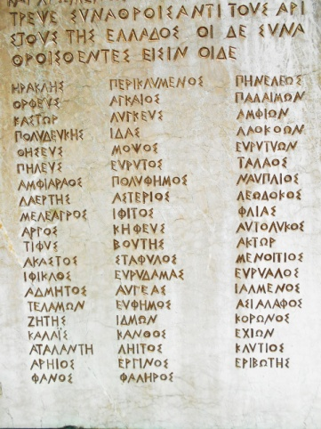
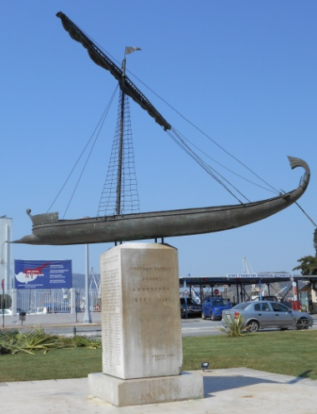
Note: This period in time, 1300 BC, is the approximate period when the legendary voyage known as “Jason and the Argonauts” occurred, sailing from Iolkos (present day Volos in the province of Thessaly, Greece) with a “who’s who” of ancient heroes on board: Hercules, Peleus, father of Achilles, Telamon, uncle of Achilles, fifty-nine in all (for a boat with 50 oars) listed on a monument today at the harbor of Volos. To arrive at the Black Sea the voyagers had to enter the Hellespont (the Dardanelles), a choke point controlled by the Trojans, and Troy a mere 4 miles (7 kilometers) south of the entrance. The legend may have some validity. Mycenaean shards (pieces of pottery) have been found along the Black Sea coast the Argo traversed. But Hercules, according to legend, holding an old grudge against the ruler, sacked Troy possibly at that period, a time when records show Troy was hit by an earthquake.

1295 to 1272 BC
Letter from a King of Ahhiyawa to a King of Hatti

Probably written to King Muwattalli II (M) during whose reign battles were fought with Egypt, the major conflict occurring in 1274 at Qadesh in Syria. The letter of about three paragraphs, the only one directly from a Greek king, is concerned primarily with disputed ownership over a group of islands which apparently lay off the western cost of Anatolia. The Greek king asserts these islands were transferred (likely around 1435 BC) to his great-grandfather (Kagamuna, possibly Agamemnon) by the Assuwan king as part of a dowry to a bridegroom (his great-grandfather) who married an Assuwan princess. The Greek king states that the gift occurred before M’s great-grandfather’s (Tudhaliya I/II - T) defeat of the Assuwans, so he is reaffirming his right of ownership. Very likely, there may have been a Hittite scribe, fluent in both Hittite and Greek, who was assigned to the court of the Greek king (whose name is unfortunately not recorded). It should also be remembered that while the Greeks at that period (15th century BC) had characters reflecting a language for inventory purposes, mainly products but people also (Linear B), they did not have a written language as did the Hittites.

The letter (clay tablet) from the Greek king written in Hittite reads, “Thus says -- Great King, King of Ahhiyawa, say to His Majesty, King of Hatti – In the previous year my brother (the Hittite king) wrote to me – ‘As for your islands that you – the Storm-God gave them to me in subjugation’” (the fact that T some 140 years ago defeated the Assuwan Confederacy). The Greek king continues, “The King of Assuwa (unintelligible) – Kagamuna his/my great-grandfather – married previously. Then T your great-grandfather, defeated the King of Assuwa and subjugated him. The islands formerly indeed belonged to the King of Ahhiyawa, and I have now written to my brother on account of this. But – examine, my brother. Further -- the household of my brother and my brother’s servants.” (In effect, check to see if this is not so.)

During this period when Muwattalli II ruled over Hatti, 1295 to 1272 BC, this incident, with the Greeks claiming sovereignty over the islands, was likely not as disconcerting to the Hittites as their disputes over territory with the Egyptians. It was in 1290 and particularly again in 1274 BC when large forces of the Hittites and those of the Egyptians collided at Qadesh at the Orontes River in Syria. Therefore, the Hittite king had much more pressing problems to deal with on his far southeastern frontier compared to Greek claims bordering on his far western territories. The Hittite king apparently accepted the Greek king’s claim. The islands claimed may have been Lesbos and Chios further south and Lemnos, Samothraki and Imbros off the coast of Troy further north.

1267 to 1237 BC
The Tawagalawa Letter (Brother of the Greek king)

Letter from a King of Hatti, probably Hattusili III 1267 to 1237 BC, to a King of Ahhiyawa. This letter was a period when part of southwestern Anatolia at Milawata (Miletus) was under the control of the Greek king, as has been archaeologically attested to, likely beginning during the late 14th century BC. This clearly reflected Greek strength in the region and leverage against the Hittites which the Greeks clearly used.

Prior to discussing the primary focus of this letter, which is very long, this the third of three clay tablets, the third only which has been found and with some words unreadable, we must focus on the last portion of the letter. It has high significance in referring to hostilities and a possible war at Troy (Wilusa) comparable to Homer’s Trojan War which Homer located at (W)iIios. The last part, parts 11 and 12 of King Hattusili III’s letter to the Greek king reads:

“And concerning the matter (of Wilusa) about which we were hostile – because we have made peace, what then? If a certain ally confesses an offense before his ally, because he confesses the offense before his ally, he does not reject him. Because I have confessed my offense before my brother – And let it (go?) no further to my brother.”

“But my brother (the Greek king) already wrote to me as follows – ‘You have used force against me.’ But I was still young (the Hittite king states). – If likewise to me – such an utterance coming from his ( ? ) mouth – the troops will be angry (say he?) is crazy. And from that – he speaks. Why will I – (make?) – such an utterance before the Sun-God. – I have used force. But now the message of my brother that came orally (by a trusted messenger, apparently so that it cannot be intercepted as a letter could be), came to the Great King (H III) – We will set this legal dispute down before ourselves. You, my brother, send me one of your servants. The one who brought you that message – that message is corrupted – let that man be beheaded. If your man has altered your message, let that man be beheaded too. Let them stew – And where will that bloodshed lead? Because your servant spoke this false message, he alone must die. If the message did not come from your mouth, then the servant ( ? ) it. Did he not determine it on your behalf? If the Great King, my peer, had spoken it, the servant would have ( ? ) it.”

Clearly there were hostilities at Wilusa (Troy) and no doubt outright war between the Greeks and the Hittites which undoubtedly included their allies, the Trojans. Apparently peace of some kind was concluded. The Hittite king (H III) seems to be confessing an offense (initiating the war) committed against the Greeks but he wants the issue to be closed. He is concerned, though, that the Greeks responded to him, “You have used force against me.” H III is attempting to rationalize it by saying, “But I was still young.” And of course H III reveres the Sun-God whom he does not want to offend. Yes, H III has used force, but now it is time to set this dispute aside. Then H III talks about corrupted and false messages and beheading servants involved.

While on the one hand H III confesses the use of force against the Greeks, he clearly has not apologized but seems to be rather blaze and defiant and lays the blame of possible miscommunication, which led to the hostilities, on the servants and asks for their beheading like this action should solve the conflict. But, I believe, it is possible the Greeks think otherwise and may likely have developed a plan or strategy of their own to rectify the hostile action of the Hittites. As H III is attempting to use excuses for the hostilities, the Greeks may contemplate the same such as Homer’s Greeks did with the abduction of Helen by Troy’s prince Alexander/Paris. If not immediate retaliation then possibly in the near future when the Hittite kingdom may be more vulnerable. While this is speculation it bares consideration. We are talking about human beings whose kingdoms have been on a warlike footing for many generations while sharing occasional moments of tenuous, peaceful co-existence. As the Egyptians in 1274 had their own interpretation of the result of their battle at Qadesh in which they declared victory, the Hittites had a different interpretation. Winners and losers at the hostilities in Wilusa were also very likely a matter of interpretation. But it appears, in any case, that the Greeks were angered.

Let us not forget, Homer was not a stranger to the land of Anatolia. He was born and raised in western Anatolia (Asia Minor) probably at Smyrna (Turkish Izmir) and later likely lived on the island of Chios just to the west. Clearly stories of conflicts and warfare in the region were handed down from generation to generation and not only transmitted in the court of kings by singing bards but possibly written down in the languages of the region such as Luwian or Phrygian and, if so, are yet to be discovered and even possibly writings by the Phoenicians, well-known traders in the Mediterranean. The “Schliemann Dump,” from unorthodox excavating techniques at Troy, may also provide new information. From the letter above, clearly there is documented evidence of the use of force and hostile action at Troy between two great powers. A large measure of mutual trust may also have been shattered.

The Main Focus of the Tawagalawa Letter

Now to return to the main focus of the Tawagalawa Letter of 1267 to 1237 BC from King Hattusili III (H III). It should be noted that H III seized the Hittite throne under a conspiracy with vassal territories in Syria to the southeast of Hatti. No doubt H III wants to consolidate and secure his tenuous reign throughout the kingdom. This lengthy letter to a Greek king concerns a renegade trouble maker, Piyamaradu (P), at the coast of southwestern Anatolia whose actions are more than irritating to H III. To further exacerbate this irritation, it is the Greek king who is providing sanctuary to P, not only on the Greek islands but also on Anatolian territory controlled by the Greeks. H III’s communication to the Greek king comprises twelve parts.

Part 1

H III states that it is apparently clear P has burnt a town including the royal compound. The people of the town appealed to the brother of the Greek king, Tawagalawa (possibly Agamemnon’s brother Menelaus), as well as to H III. P asked that a Crown Prince of the Hittites be sent to escort him to King H III at Hatti. But then P belittled the Crown Prince and wanted himself crowned king “on the spot” or he will not come. Crowned he wasn’t.

Part 2

H III traveled to the region in dispute (Lukka in southwestern Anatolia) where he was engaged in battle which was prompted by P. The brother of P (Lahurzi) ambushed H III in the territory of Iyalanda. H III asks “my brother” (the Greek king) to inquire to see if this did not happen. “I, Great King, have sworn that these things about which I have written to you indeed took place. May the Storm-God listen, and may the other gods listen to how these things happened.”

Part 3

H III states he has destroyed the entire land called Iyalanda but his forces were small so he withdrew. He says he wrote to P “‘Come here to meet me. – I have lodged a complaint against him in this matter, that P keeps attacking this territory of mine.’ Does my brother know it or not.”

Part 4

The Greek king sent a message to H III, but H III complains “he did not bring me any greetings or a gift.” But he did bring a message for the local official to “Turn P over to the King of Hatti,” a gesture of kindness from the Greek king. But P departed by ship apparently to a nearby island even though P was given safe conduct if he came to H III. “Why did he not meet me?” H III asks. Did P believe, “I feared an assassination plot?” But H III stated, likely in a coy manner, “As for the assassination plot about which he is afraid -- is bloodshed permissible in Hatti? It is not.”

Part 5

H III states that the Greek king, “my brother,” already sent a message that P be taken to Hatti and he further states, “should I not listen to the word of my peer?” But he says he did accommodate the Greek king by coming to meet with P (if there was correspondence from the Greek king to that effect we do not have it). But P continues to avoid H III out of fear of reprisal.

Part 6

H III says, “out of consideration for my brother (the Greek king) I have done nothing (to P).” I sent my charioteer to P. My charioteer is a worthy man who used to ride with me in my youth “and often mounted a chariot with your brother Tawagalawa.” I offered P safe conduct. I wanted him to “Come and give me an explanation” for his actions which I will relay to you. If P is not satisfied I (H III) will have my charioteer take P and return him to you (to the Greek king). If you are concerned “let the charioteer stay as a hostage” but take care of him.

Part 7

H III says that “Many civilian captives have slipped across to your (apparently the Greek king’s) territory, and you my brother have taken 7000 civilian captives from me.” (The rest of the communication is confusing, something about his man coming as a fugitive – he shall remain. But if compelled to come – to Greek territory – he should be returned.)

Part 8

H III says “Whether (the fugitive) is a nobleman or a slave” let him come back, my brother. “If some servant of mine flees from me will you – run after that one?”

Part 9

H III continues to question the Greek king about P: “While he leaves behind his wife, children, and household in my brother’s land, will your land support him? This person keeps attacking my territory – Do you approve my brother?”

Part 10

Give P choices, H III says. Have him come to me at Hatti and I will reconcile with him. If not, P should come over to your land or resettle in another land like Karkiya or Masa. Tell him “‘So long as you are hostile to the King of Hatti, be hostile from another land!’ (Also the Greek king should tell P), ‘The King of Hatti has persuaded me about the matter of the land of Wilusa (Troy) concerning which he and I were hostile to one another, and we have made peace. Now hostility is not appropriate between us.’ Send that to him.” (This latter statement refers to the war between the Greeks and Hittites at Troy in 1250 BC in which P either knew of or may have had some involvement.)

Parts 11 and 12

This lengthy communication concludes here. This is where the details discussed at the beginning of this text, written by Hattusili III, who usurped the throne from his nephew, and ruled Hatti for thirty years, 1267 to 1237 BC, are documented. As introduced in the above part, it talks about how the Greek and Hittite kings were engaged in hostile acts in the territory of Wilusa (location of the city of Troy). H III confesses he has committed an offense but, as you recall, he states “But I was still young.” Yet the Greek king voices consternation that “You have used force against me.”

Commentary

Contrary to the scorched earth policy of systematically defeating the many vassal states hostile 50 years earlier at the beginning reign of Mursili II, father of H III, H III himself, though highly irritated at a troublemaker P and occasionally responding forcefully, has taken a more measured approach at the offenses of P. This in large part reflects the support P is receiving from the Greek king who is also providing him and his people sanctuary on Greek territory. The Greeks, who for some generations have been attempting to gain territory in Western Anatolia, are now no doubt using this leverage wisely since the Greek king also controls land at Milawata (Miletus) in southwestern Anatolia in the backyard of the Hittites. (No doubt complicating matters for the Hittite king, the Greek ruler was married to the daughter of P.) H III wants the Greek king to use his influence to convince P to meet, under safe conduct, at his capital of Hatti. P continuously refuses under fear of reprisal or assassination.

But P has burnt a town including the royal compound and ambushed, through his brother, the Hittite king and his army. In reprisal H III has destroyed an entire land. Despite this the friendship between the Greek and Hittite kings is seemingly still close, not only with laudatory words by the Hittite king in often calling the Greek king “my brother, “my peer,” and “Great King,” but also the Greek king’s brother, Tawagalawa, was sent to help settle the issue. It often appears like dialogue at a family gathering, but probably a Mafia gathering where big egos and honor among thieves are at stake. And H III swears by the “Storm-God” that what he is saying is true, and “Does my brother know it or not?” H III, though, is clearly upset that when the Greek king, in sending a message, “did not bring me any greetings or any gift” (which is typically done), though the message sent did request that P be brought to the Hittite king. H III continues to tell the Greek king that he has given safe conduct to P even sending his own charioteer to escort P. And if the Greek king is not satisfied he can hold the charioteer hostage.

But then H III complains continuously that many civilian captives of his have slipped into Greek territory “and you my brother have taken 7000 civilian captives from me.” H III clearly wants them back saying “If some servant of mine flees from me will you not run after that one.” (Linear B tablets found at Pylos in southwestern Greece reveal that slave women from Miletus as well as Chios and Lemnos worked in the textile operations of the ruling king at Pylos.)

The bottom line for H III is that “This person (P) keeps attacking my territory” and he asks the Greek king “Do you approve my brother.” Apparently the Greek king does since P is in essence acting like his agent. In exasperation H III tells the Greek king to give P three choices: 1. Let P and I reconcile our differences, 2. Settle him in your land, or 3. Resettle him in another land. But I do not want him hostile to me from my land.

Finally H III brings up hostilities they both had against each other at Wilusa (Troy) of which P may have played a part. But it was settled peacefully, at least it appears that way, though the Greeks may be harboring resentment against the hostile offenses that H III confessed to. In fact, there may be resentment on both sides: The Greeks due to H III’s desire to secure his territory in western Anatolia, a great distance from their capital city of Hattusa, an area which the Greeks have coveted for many years, and the Hittites for their anger not only at the renegade P, who may have also fought at Troy, but also the Greeks openly undermining their authority in the region and destabilizing the territorial integrity of the Hittite kingdom. This may be the underlying theme playing out here. If so, a showdown between the two powers may be the only solution as occurred some 180 years earlier in 1430 BC which the Greeks, even with a rather powerful fighting force, were defeated by the Hittites. Revenge may finally be on the mind of the Greeks. Animosities on both sides are likely growing.

Note: In an unprecedented move by the Egyptians, Pharaoh Ramses II married the eldest daughter of King Hattusili III in 1246 BC. Ramses II ruled from 1278 to 1212 BC. He earlier signed a peace treaty with the Hittites in 1259 BC concluding their war at Qadesh of 1274 BC. This peace no doubt benefited both kingdoms particularly with Hittite trouble with the Greeks at Wilusa (Troy), and other territory in the far west including rebel vassal states during the mid 13th century BC, and in Egypt the Exodus of the Israelites also during that period.

1237 to 1209 BC - 1
The Milawata Letter by Tudhaliya IV

This letter of seven parts deals primarily with clarifying the territory of vassal states of the Hittite kingdom in western Anatolia and the rulers King Tudhaliya IV put in place. P, though, continues to cause havoc, this time for T IV, the son of H III.

We are now in the waning years of the new Hittite kingdom which has existed for some 500 years (as have the Mycenaean kingdoms). T IV is likely the last “Great King” of that empire. Arnuwanda III reigned only two years more, 1209 to 1207 BC, and Suppiluliuma II, the very last king whose reign began in 1207 but with a weakened kingdom ending around 1180BC. The final chapter to all the kingdoms in the eastern Mediterranean, save Egypt, came to a drastic, fiery end in the early 12 century BC. It has been clearly and interestingly documented by Eric Cline in his book, 1177 B.C.: The Year Civilization Collapsed, 2014. While Cline confirms, in the book and in a brief meeting with me in his office, the collapse did not occur in one year alone but took several years, major events occurred during the very late 13th and early 12th centuries BC which collectively affected the palatial sites of the ruling elites. H III, between 1267 to 1237 BC, had difficulties in maintaining any semblance of control in the western frontier, both with a rebel, P, plus the strong influence of the Greeks in that area. Now after 1237 BC, while P continues his aggressive tactics, the Hittites may briefly have regained control of the territory the Greeks held, but this is not certain. T IV has partnered with Tarkasuawa, who he has put in control of certain western territories including the boundaries of Milawata, formerly subject to the Greeks. This partnership is unprecedented in Hittite history and may reflect a desperate attempt at some kind of control. This is a very difficult time for the Hittites particularly since in 1237BC they lost a war with the Assyrians to their southeast, both battling over the Kingdom of Mittani situated between them, and in 1225 BC the Assyrians defeated the Babylonians to their south and again defeated the Hittites in 1209 BC.

At the same time, T IV is hoping to reinstate Walmu as the ruler of Wilusa (Troy) in the region of the classical Troad, from which he was dethroned earlier by a rebel group, maybe led by P. This rebel group was surely supported by the Greeks but we cannot be certain. In the letter T IV says, “I will put my trust in your good will (Tarkusuawa). Turn Walmu over to me, my son, so that I may reinstall him in kingship in the land of Wilusa. -- He shall be our military vassal as he was formerly.” It should be noted that some 65 years earlier in 1290 BC through 1272 BC, Wilusa, through a lengthy treaty prepared by the Hittites, was ruled by Alaksandu, a name virtually the same as Homer’s Alexander, the Paris who abducted Helen. This has led some linguistics to surmise Alaksandu may have been Greek, possible from a concubine of the rulers.

1237 to 1209 BC - 2
Treaty Between T IV and Shaushga-Muwa, King of Amurru (Syria)

This is the very last text in the 220 years of dialogue and communication relating to the Ahhiyawans, the Mycenaean Greeks, and the Hittites which had been discovered at the Hittite capital of Hattusa beginning in 1906. And only a few lines of this long twelve part letter refers to the Greeks. We are beginning to see the demise of the Greeks in the eyes of the Hittite rulers. That is, no longer are the terms “Great King,” or “my brother, or “my peer” used. Also in this letter which is an agreement, a treaty, and communication between T IV and his vassal state in Syria (written likely 1225 BC), all the lists of “Great Kings” were included, including the Great King Ahhiyawa (likely inserted by mistake by a scribe) but then the name was erased!

It was common, as we have seen and as even today, that relatives such as sisters or brothers or daughters of rulers would marry foreign rulers to create alliances among the countries. The Hittites did that with the western frontier vassal states (as we recall the Greeks did) and have done it here with Shaushga-muwa, who married the sister of T IV, and was made by T IV ruler of Amurru, territory along the coast of present day Syria. The Hittites, as you recall, fought battles in that region, the major conflict being at Qadesh in 1274 BC. Originally ruled by Egyptian Pharaoh Seti I, his son Pharaoh Ramses II later relinquished that territory to the Hittites through a peace treaty in 1259 BC well documented with discoveries made at both Hatti and Egypt.

T IV is admonishing S to be and remain loyal to him saying, “I, My Majesty, Great King, have taken you, S, by the hand and have made you my brother-in-law. I have given you my sister in marriage and have made you king in the land of Amurru. Be loyal to My Majesty in regard to authority. – Let this matter be placed under oath to you.” Furthermore, he states, “You shall not desire anyone for authority among those who are legitimate brothers of My Majesty or sons of concubines of the father (H III) of My Majesty.” In other words, no other of T IV’s family members are to be trusted whatsoever.

T IV is clearly attempting to secure not only his authority and the integrity of his kingdom but also warning S about not involving any of T IV’s relatives, who might oppose the king, in any matters of authority as well. In the previous letter it was also a matter of his authority in the western territories. Though his grandfather, Muwattalli II, fought two wars at Qadesh against the Egyptians, he says of alliances, “If the King of Egypt is the friend of My Majesty, he shall be your friend. But if he is the enemy of My Majesty, he shall be your enemy.” He states of Assyria, further east of Amurru, “Since the King of Assyria is the enemy of My Majesty, he shall likewise be your enemy. Your merchant shall not go to Assyria, and you shall not allow his merchant into your land.”

This period, 1237 to 1209 BC, clearly reflects defining times for the various kingdoms of the eastern Mediterranean and Near East. We have observed that over the last 220 years the communications among the various rulers, from grandfather to son to grandson to great-great- grandson in the genealogical line, has focused primarily on control of territory by central authority, hostilities, outright warfare, and underlying animosity and intrigue. Intrusions into western Anatolia and Cyprus by the Ahhiyawans, the Mycenaean Greeks, as well their fomenting unrest among the vassal states, have been a constant threat and source of deep concern for the Hittite rulers. While Greek control may have waned in western Anatolia, the Hittite king had to form a “partnership” there with a vassal state, showing weak central authority. T IV in the southeastern frontier is also “forming an army and a unit of chariotry” for hostilities against the Assyrians and that “it is matter of urgency” that S do the same for himself. And he also commands his brother-in-law emphatically, “You shall not allow any ship of Ahhiyawa (the Greeks) to go to him” (the King of Assyria).

This is the very last of the communication which deals with the Greeks. T IV clearly wants to stop all trade with Assyria, his enemy, including banning any Greek shipments. One scholar (Bryce 2010) interpreting the letters has speculated these Greeks may be Mycenaean mercenaries out for hire and not subject to any Greek kingdom. This may or may not be the case.

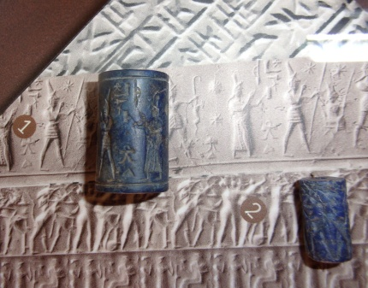
Note: T IV did in fact attack Cyprus during this period bringing the king, his family, and other captives and goods back to Hattusa. Later, S II during his reign did the same. But as much as T IV gathered an army against the Assyrians and warned his vassal at Amurru to do the same and placed an embargo on Greek ships, the Assyrians in 1209 BC, the last year of T IV’s reign, defeated the Hittites to their northwest as they earlier did in 1237 BC. Likely it was at this time (1209 BC) that the Assyrian king sent a gift of lapis lazuli cylinder stone (a precious stone from Afghanistan) to the king at Boeotian Thebes in Greece. See photo of possibly the same cylinder seals (3/4 in. - 1.9 cm) found at Thebes as shown at their archaeological museum. This raises a question: Were there deteriorating conditions at that time on mainland Greece, or not? You will recall, the Assyrians also defeated the Babylonians in 1225 BC.

1205 BC
Letters to Ammurapi of Ugarit

Two letters unearthed at archives discovered at Ugarit in coastal Syria identify the last known references to Ahhiyawans in the Late Bronze Age. Both are from the court of the Hittites, one from the last king, Suppluliuma II (S) who ruled from 1207 until the collapse of the kingdom and the second from a Hittite official. Both were sent to Ammurapi, King of Ugarit. The letter from the king reads in part, “Concerning those owing a service obligation – I have been told that the Ahhiyawan is tarrying in the land of Lukka (southwestern Anatolia), but there are no copper ingots for him. In this matter don’t tell me that there is no appropriate action. Give ships to Satali (whom I have sent you) so that he may take the ingots to the Ahhiyawans.”

The Ahhiyawans were more likely in fact mercenaries or adventurers hired by and in service to the Hittites to either protect their western frontiers or engage in naval battles around Cyprus in support of the Hittites. The copper ingots were likely payment for their services. S rebukes the king of Ugarit for not taking action in this matter. These Greeks may have been remnants of Mycenaeans who lived in the region or came there after possible upheavals on the Greek mainland and islands.

As shown in the previous letter the name “Great King,” according to the Hittites, no longer applies to the Ahhiyawans. From this, though, we cannot assume that the letters imply that the Greeks are no longer a power in the Aegean but that by 1225 BC and after, they are no longer considered “brothers” but clearly enemies. And to the king of Ugarit, do “not allow any ship of the Ahhiyawans to go (to the King of Assyria,)” enemy of the Hittites.

The Ahhiyawans who remained in Anatolia, whether as possible mercenaries or adventurers (or maybe migrants in search of new opportunities as archaeology has attested to including as far as the Levant, the Philistines, likely Mycenaeans) may reflect some of the animosities described by Homer between King Agamemnon and Achilles and among other warriors during the Trojan War. Even Achilles wanted to return to his homeland Phthia instead of fighting Trojans, who never did him harm, for a king, Agamemnon, he despised. Disgruntled and weary warriors returning from a long and lingering ten year war are certainly prime candidates for new opportunities. Fragments from the “Epic Cycle” document many of the adventures of these Greek “war heroes,” some whose ships were blown off course and they settled elsewhere and may even have joined with the illusive “Sea Peoples” who plied the eastern Mediterranean. Several of the eastern kingdoms fought to protect themselves from the onslaught of these so-called Sea Peoples who apparently burnt and ravaged towns and villages, but it was only the Egyptians who were able to defeat them, once in 1207 BC and again in 1177 BC.

Where there is no clear evidence, either archaeological or literary, we have theory and speculation, our best guess. But what we do know is that archaeologically this earth has yielded little of what it harbors. It would be unprofessional if not unethical to make firm judgments without solid evidence, solid research to support one position or another. But clearly with sound investigative work, piecing together, whether through inductive or deductive reasoning, the bits and pieces of information from the sundry sources we now have available, most notably “The Ahhiyawa Texts,” we can reach reasonable conclusions. A further step in that direction is a more detailed analysis of the data from the 220 years covered by these texts summing up the results into “Behavioral Scorecards” which follow the analysis.

Descriptive and Analytical Summary of the Evidence

From these texts we have literary evidence, a sequence of events that occurred over a 220 year period, events as interpreted and written by the actual players, ruling kings and court officials of two major kingdoms of the Late Bronze Age. Its’ prime importance, for purposes of this writing is three-fold: 1. To clarify and better understand historical reality of the eastern Mediterranean as voiced by those humans who lived and controlled many of the events that occurred at that time, 2. To shed light on the possible historicity of Homer’s Trojan War and related events of that period, and 3. To understand the context of that period as it related to the Mycenaeans and the events at the end of the Late Bronze Age which led to the demise of the many kingdoms in the eastern Mediterranean.

As an attempt to describe and analyze these texts, this communication and dialogue, from “The Human Side of Archaeology,” that human face, as opposed to the usual fortresses, temples, artifacts and particularly shards (pieces of pottery), and other physical attributes, a summary of the events as described by these “Voices from the Past,” is shown below.

1430 BC
- Atarissiya, from the land of Ahhiyawa, Mycenaean Greeks, attacked territory in western Anatolia east of the island of Lazpa (Lesbos). The Hittite king, Tudhaliya I/II, repulsed the attack. That territory was a state apparently controlled by Tudhaliya I/II from Hattusa, his capital, a distance of about 450 miles (750 kilometers) from the region. Scholars have identified Attarissiya as Atreus, King of Mycenae, whom Homer identified as the father of King Agamemnon. Subsequent to the attack, the king of the region, Madduwatta, swore an oath of vassalage to the Hittite king.
- Madduwatta, himself, attacked territory to his south necessitating intervention by the Hittite army, who again rescued him.
- Atreus attacked Mudduwatta a second time. Again the Hittite king, Tudhaliya I/II, repulsed the attack. Atreus had 100 chariots and several thousand infantry.
- Mudduwatta continued with his intrigues, seizing Hittite towns and involving other kings in the region, some twenty two (very likely from Wilusa, the Troad, to the north, to Seha River Land and Arzawa to the south and beyond). The Hittite king in turn destroyed the twenty two countries involved in this rebellion known as the “Assuwan Confederacy.”
- In 1991, a sword said to be of Mycenaean design, was discovered at Hattusa commemorating the victories of the Hittites.
Result: Two attacks on Anatolian soil by heavily armed Mycenaean Greeks east of Lesbos and south of Troy failed. Rebellions of the western Anatolian kings crushed by the Hittites.

1390 to 1380 BC
- Mycenaean Greeks raid the island of Cyprus.
- Mudduwatta joined with the Greeks.
- King Armuwadu I of the Hittites emphatically asserts that Cyprus is his.
Result: Hittite control of its vassal states in western Anatolia continues to be tenuous.

1320 BC during reign of 1321 to 1295 BC
- Early in his reign, King Mursili II of the Hittites, launched decisive attacks on rebellious vassal states in western Anatolia centered at Apasa (Ephesus) aggressively chasing and subjugating them bringing several thousand captives, up to 66,000, back to the capital of Hattusa.
- The rebellious states were supported by the Mycenaean Greeks who subsequently follow a more peaceful route.
Result: Continued intrusion by the Greeks into Anatolia, in support of rebellious Hittite vassal states, failed.

1310 BC during reign of 1321 to 1295 BC
- Hittite king, Mursili II, is ill and requests an object of a healing diety from the Greeks.
- Objects from Ahhiyawa and Lazpa are sent to Mursili II.
Result: Friendly relations exist between the Ahhiyawans and the Hittites.

1300 BC during reign of 1321 to 1295 BC
- Stepmother of King Mursili II was put on trial by the king and banished to Greek territory.
Result: Friendly relations continue.

1295 to 1272 BC
- Letter from a Greek king asserts the islands in the northeast Aegean coast off Anatolia are his transferred earlier in time (1435 BC) through a dowry to the Greek king’s great- grandfather, Kagamuna (probably the earliest documented evidence of a Greek ruler).
- The Hittites, at war with the Egyptians in 1290 and 1274 BC, apparently did not dispute the Greek claim.
- A later letter shows King Alaksandu (similar to Homer’s Alexander/Paris), now rules Wilusa (Troy).
Result: Cautious peace in the region (with Greek territorial claims likely to increase).

1267 to 1237 BC
- Greeks have been controlling territory at Milawata in southwestern Anatolia for some sixty years.
- Greeks and Hittites engage in warlike hostilities at Wilusa but tenuous peace ensued.
- The Hittite king, Hattusili III, confesses an offense against the Greeks but the Greek king is likely irritated saying “You have used force against me.” The Hittite king rationalizes, “But I was still young,” and uses servant’s miscommunication as possible scapegoats. But there is no apology to the Greek king.
- Greeks again support rebellion by vassal states in western Anatolia, supporting P in this effort, and securing captives from these states, with the Hittite king attempting to appease the Greeks with kind rhetoric.
Result: Outright hostilities between Greeks and Hittites at Wilusa (Troy). While now at peace, animosities appear to continue to escalate.

1237 to1209 BC
- A renegade, Piyamaradu, whom Greeks support, continues havoc in western Anatolia.
- Hittites possibly gain control of Milawata (Miletus) from the Greeks (but maybe not).
- Walmu reinstated as ruler of the state of Wilusa (Troy) by the Hittite king (maybe not).
- The reference to the Greek king as “my brother,” “my peer,” and “Great King,” is erased from Hittite letters.
- A boycott against shipping of products from the Greeks to the Assyrians is instituted by the Hittite king, Tudhaliya IV, through treaty with the king’s brother-in-law whom the king placed as ruler of Amurru, in present day coastal Syria.
- Hittites prepare for war against Assyria, present day Iraq, in their far southeastern frontier, a war they eventually lost, in fact losing two wars; 1237 and 1209 BC.
Result: Communication and co-existence between the two great powers, Ahhiyawans and Hittites, have come to an end. Havoc continues in the western frontier while outright warfare ensues in the far eastern region. It is a very tenuous time in the entire eastern Mediterranean.

The warlike character of the Ahhiyawans (Mycenaean Greeks) brought them into continuous hostile contact with the Hittites of Anatolia. While their capital of Hattusa was over 450 miles (750 kilometers) from the coast of their western frontier over mountainous terrain, a great distance even by chariot, the Hittites attempted to secure, often violently, their authority over the vassal states they established. It was two warlike powers colliding with each other. It is interesting to note that the vassal states were virtually during the entire 220 years in constant rebellion against Hittite rule. In fact, the cultures of western Anatolia, along the entire eastern Aegean coastline, most likely had more in common, culturally and economically (as archaeology alludes to) with the Aegean cultures as compared with the land-locked Hittites. Through constant contact via trade routes and colonies, the Greeks attempted to secure territory and its resources to include Wilusa, Homer’s Wilios – Troy.

The “Scorecard” below and the statistical summary provide an analytical overview of the results of 220 years collaboration between the Ahhiyawans and the Hittites. While simple in format it attempts to highlight the human dynamics that occurred between these two great powers.

Table 1. Behavioral Scorecard

Behavioral Categories

BC Outright Warfare Hostilities Animosities Captive Taking Diplomacy Peace

1430 2 by Greeks (Troy?) Many by all Many by all Thousands
22 by Vassal states sides sides to Hatti
Victory by Hittites
1390- 1 by Greeks Many by all
1380 in Cyprus sides
1320 Many vassal By Greeks Many by all Thousands
States sides to Hatti
Victory by Hittites
1310 Guarded Greeks
optimism seek peace

1300 Alaksandu Peace
rules Wilusa both sides
1295- Both sides Greeks claim Guarded
1272 islands peace
1267- Greeks and At Wilusa Many by all To Greek Greeks Very
1237 Hittites at both sides sides territory control Miletus tenuous
Wilusa (Troy) + P a rebel + to Hatti
1237- P continues Greek “Great To Hatti from Hittites control (?)
1209 Rebels at King” erased Cyprus Miletus but maybe
Wilusa (Troy) Boycott Gk ships not Wilusa (Troy)

Table 2. Behavioral Scorecard Summary

110 I 110 yrs.
100 I 50%
90 I 1430-1320 BC
80 I
70 I
# of Years 60 I
50 I 50 yrs.
40 I 23% 40 yrs.
30 I 1320-1270 BC 18%
20 I 1270-1230 BC 20 yrs.
10 I 9%
0 I________________________________________ 1230-1210 BC_____
Warfare Peace Warfare and Cessation of
Tenuous Peace Communication
Behavioral Categories
(Interwoven Throughout with Animosities and Latent Hostilities)

During the 220 year period, 110 years, fully one-half or 50%, 1430 to 1320 BC, was devoted to warfare; 50 years, 1320 to 1270 BC, 23%, devoted to peace; 40 years, 1270 to 1230 BC, 18%, warfare and tenuous peace; and 20 years, 1230 to 1210 BC, 9%, total cessation of communication. These statistics clearly show that while there was an apparent period of peace, some 50 years, there was throughout the entire 220 years underlying hostility and animosity among these two great powers reflected in the 68% combined “Warfare” and ‘Warfare and Tenuous Peace,” statistics corroborating the warlike character of the Mycenaean Greeks and equally the same for the Hittites. (If a “Scorecard” was provided for the Minoans, it may show the opposite: 70% peace and only 30% - and even less - warfare.) For our two great powers, this is some 150 years of often bloodshed, death, captives for slavery, depopulation and lose of homelands through migration of people from war zones (as this is occurring even today over 3000 years later) deposing of rulers, oaths of allegiance by vassal states to the victors including securing males for military service (conscription). These no doubt were carried out for numerous reasons but clearly humanly driven: Expansion of the empire (territorial greed), power and control over others (self aggrandizement and megalomania tendencies), desire for and control of resources (symbols of position, status and national pride), gods’ will and cult worship (religious fervor which was and continues to be a very strong motivator), conspiracies to gain a position of power (subversion of cultural expectations). These relate more to ruling elite “wants” not necessarily “needs”. From a human perspective these “wants” clearly had an enormous impact on societies, families, and the daily lives of people, an impact principally from “greed,” “personal gain,” and “entitlement,” not natural environmental events (which will come into play in the discussion later on the collapse of these kingdoms).

But there was also a period of peace – some 50 years. There clearly were intervening variables that created behavioral change in the Greeks - from hostility and warfare to co-existence. Their continuing defeat at the hands of the Hittites and the defeat of the vassal states they supported were likely the variables at the top of the list. Intermarriages among the ruling elites of the kingdoms, though not known during the period of hostilities from 1430 to 1320 BC, did occur during the period of peace, 1320 to 1270 BC and again during the occasional tenuous peace of 1270 to 1230 BC as have conspiracies. These interventions may have created some local instability but generally a more stable international environment among the powers. Greek rule over the territory of Miletus must also have been a variable forcing the Hittites to be more diplomatic despite Greek support of the rebels attacking the Hittite vassal states. Psychologically this “behavior modification” can be a valuable tool particularly where the stakes are high such as on the international stage. Through the ages, and even today, leaders individually or collectively have intervened to force behavioral change among the rulers of more belligerent nation states or have invaded or seized territory to force cultural change or create “vassal states.” While there were moments in these letters when we saw a king’s humanity and benevolence (such as King Mursili II, 1321 to 1295 BC, showing mercy after a mother’s appeal and rebuilding towns his army destroyed) they reflect behavioral characteristics and qualities of leadership of firm dictatorship and strong central authority characteristic of the ruling dynasties of the Late Bronze Age.

In attempting to understand the ancient societies above and the people who ruled them, “The Ahhiyawa Texts,” have been transformational. The insights they provided are invaluable. While notable authors such as Cline, Rose, Hoffner, Latacz and others, and particularly German and other scholars and linguistics, have investigated and written about these texts and other events as well as their interface with the Trojan War of the Iliad, it is hoped that the general audience will gain a better perspective of that time from this overview, the behavioral implications of the rulers, and the overall impact on the controversies surrounding Homer.

Are the Texts the “Smoking Gun?”

Now for that “Smoking Gun” controversy, as Cline mentioned, of whether these texts support any of Homer’s Trojan War. Was there a Trojan War? Definitely YES. Was it Homer’s Trojan War? This continues to be the baffling question. This 220 years of communication - 1430 to 1210 BC – though not vindicating Homer, does provide some evidence for that possibility. Scholars already agree that his “Catalogue of Ships” in the Iliad is authentic, that it clearly identifies Late Bronze Age palace sites in Greece. Also the weapons of war identified in the Iliad were used during the Bronze Age like boar tusk helmets and the shields and swords while other factors mentioned by Homer reflect Iron Age realities like languages spoken by Trojan allies. There is general agreement that Ahhiyawans in these texts refer to Mycenaean Greeks. Settlements and colonies in Anatolia, facilitated by extensive trade including the desire for precious metals, luxury goods, raw materials and other goods and services, were forged by the Minoans which the Mycenaeans inherited. The Mycenaeans likely believed they had a legitimate right to expand their territory eastward particularly noting that many of the kingdoms in western Anatolia were vassal states of the Hittites that were often rebellious against the Hittites. The Mycenaeans were powerful and warlike, already having overtaken the Minoans, and had the means and the will to wage war. The powerful kingdom of the Hittites rose to resist this. This is no different a scenario than what humanity has been experiencing during our own lifetime. (It is interesting to consider, if the Hittites did not rise to resist the Greeks, how would history have evolved with a Mycenaean Empire extending far to the east approaching the Syrian coast? Would the empire have been strong enough, like the Egyptians, to resist the intrusion of the Sea Peoples thus softening the blow to the collapse of the Late Bronze Age and the Dark Age to come? How would this have affected biblical history and the ensuing power struggles in that region? )

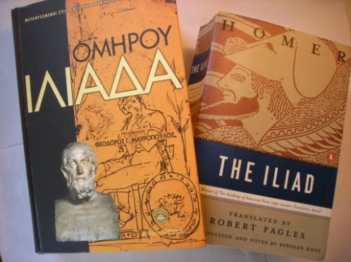
Homer has been honored by many and assailed by others (as has Schliemann, first major excavator at Troy). Yet what he did was relate for posterity what many term “The greatest war story ever told.” It is a story that has brought enormous pleasure to generations of readers, a glorious framework to the early history of Greece, ancestral roots for the Romans, and to the present day, innumerable job and research opportunities for professors, archaeologists, historians, philologists, and many other scholars and students of ancient history who clearly owe Homer an enormous debt of gratitude. For art dealers, museums and private collectors, the artifacts dealing with the Trojan War and its players are almost impossible to enumerate.

Robert Fagles, a translator of the Iliad, whom this author was honored to communicate with over the phone some years ago, said in his 1990 book that Homer “sweeps along the listener – there is something powerful in his song – (and the fire in Homer) burns everywhere clearly, and everywhere irresistibly.” Homer’s intertwining the socio-emotional dynamics of the war may be one reason. In additional fairness to Homer, he did not set a date for his Trojan War, we have done that, from ancient writers down the present, though Pausanius nearly 2000 years ago chose not to get involved in the Trojan War controversy. Typically the war has been dated to 1250 BC or 1180 BC. This period does coincide with the war at Troy fought during the Hittite reign of 1267 to 1237 BC, though not the later date of 1180. The dates associated with Homer’s Trojan War may or may not fit the evidence from “The Ahhiyawa Texts.” 1430 BC there were two enormous clashes in the vicinity of Troy fought by the Greeks and the Hittites and likely their allies. Several vassal states in that northwestern region of Anatolia also rebelled against their Hittite rulers. The Greek attacks and the rebellious states were all crushed by the Hittites. The Greeks continued their intrusions into western Anatolian including the far eastern Mediterranean on the island of Cyprus. For decades the Greeks supported rebel groups hostile to Hittite rule and eventually gained control of territory, Milawata (Miletus), in southwestern Anatolia. During the period 1267 to 1237 BC they fought the Hittites specifically at Wilusa (Troy). Although there was no direct mention that the Trojans were involved, as a vassal state they must have taken part. This time the Greeks were not defeated but peace ensued between the two powers - a stalemate. The Greeks continued their intriguing tactics supporting rebels against the Hittites. Finally during the period 1237 to 1209 BC, communication between the two powers came to an end. The Hittite king had the term “Great King” erased from any discussion of the Greeks. An embargo was put in place forbidding their vassal state in Syria to allow Greek shipments to the enemy, Assyria. No where during the 220 year period does the evidence from the texts show that the Greeks directly fought and defeated the Trojans. Then again, the texts are principally the Hittite version of what transpired. The question clearly remains, after communication ceased in the late 13th century, What happened to the Mycenaean Greeks? And what happened in the entire region of the eastern Mediterranean?

Collapse of Civilizations of the Late Bronze Age

Nancy Sandars in her book, The Sea Peoples, 1985, says of the destruction and demise of the many civilizations of the eastern Mediterranean, “The hallmark of the times is movement.” It is an excellent, though inconclusive writing, about the marauding “Peoples of the Sea,” an elusive “army” who were believed to be a composite of several cultural groups from the Mediterranean, that had originally been the prime suspects in the destruction of the palace centers of that region. Their presence has been clearly attested to on Egyptian carvings, reliefs, with accompanying inscriptions on the north wall of the Great Temple at Medinet Habu showing attacking boats and men in horned helmets and others in feathered crowns and a much larger fleet of Egyptian boats in the scene. But to the ancient Greeks it was the “Dorian Invasion” from the north which was to blame, the family of the “Heraclids,” descendants of Hercules, who at a time when Greece was vulnerable descended likely from the mountainous region of Epirus in northwestern Greece, west of Thessaly, to overrun the country. Though no archaeological evidence has been found to support this Dorian version, the tradition remains strong. Some have pointed to the fortification wall built at that time at the Isthmus of Corinth and facing north as evidence of fears of invaders from the north, and likely the Dorians.

But there were greater forces at work at that time that led to what has been described as a “Systems Collapse,” and other catastrophic events, versions of which Sandars also alluded to in her book, and that archaeologist Colin Renfrew first described in 1979 and which Eric Cline in 2014 clearly documented and elaborated on eloquently in his previously mentioned book, 1177: The Year Civilization Collapsed. He identified Renfrew’s “Systems Collapse” as:

- Collapse of the central administrative organization
- Disappearance of the traditional elite class
- Collapse of the centralized economy
- Settlement shift and population decline

These happened through time. But as Cline believes, “The period of the Late Bronze Age has rightfully been hailed as one of the golden ages in the history of the world.” To bring such cosmopolitan, elitist and often warring societies to an end must therefore have been factors more complex than marauding sea pirates and collapse of the palace system itself, all which occurred within the context of other intervening events. Though not all scholars agree, a “Complexity Theory,” which evidence points to, appears to be a logical answer. This includes:

- Earthquakes, seismic activities which have affected the region for centuries, often leveling entire cities.
- Drought brought on by changing climatic conditions which eventually leads to famine.
- Invaders destroying, burning and pillaging villages, towns, and cities.
- Migrants fleeing from impending doom, war zones, and others caught in the crossfire.
- Internal strife and civil unrest against ruling elites much which we have already seen in western Anatolia.
(And possibly 6. Plagues, viruses, such as today in 2020 with the global Covid-19 pandemic.)

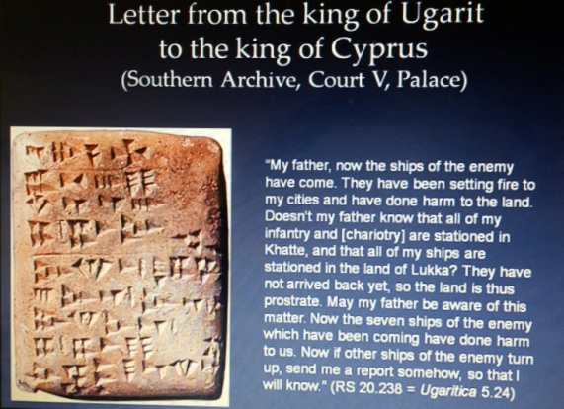
In combination, this mosaic of events created a domino effect that systematically brought the palatial period, driven by international trade and scribes the vital linguists and record keepers, to an end. Consider evidence from a clay tablet found at Ugarit on the Syrian coast pointing to fear from an enemy causing havoc. Addressed to the king of Cyprus from the king of Ugarit, it reads in part: “My father, now the ships of the enemy have come. They have been setting fire to my cities and have done harm to the land. Doesn’t my father know that all my infantry and -- all my ships are stationed (far away) in the land of Lukka?” (See tablet from Eric Cline.) The enemy very likely refers to the sea peoples who first attacked Egypt in 1207 BC and later in 1177 BC, both which Egypt repulsed. The destruction at Ugarit, which was violent, has been determined to have occurred between 1190 and 1185 BC. Other towns in the region were also destroyed. One area not destroyed was further south on the Levant coast, a city called Ashkelon. Here excavators found the appearance of new cultural patterns and connected them to the Philistines, identified as the Peleset, part of the marauding “Sea Peoples” who migrated from the Mycenaean world of the Greeks.

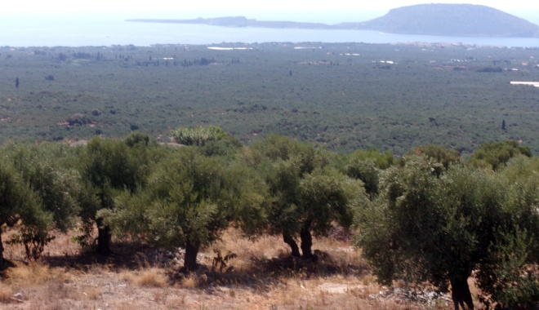
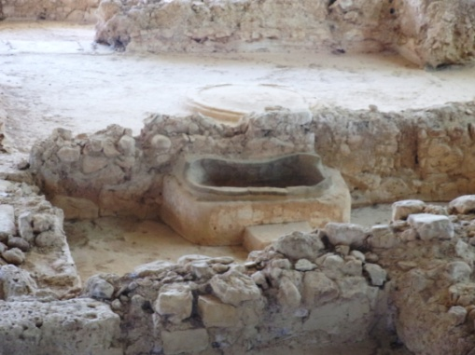
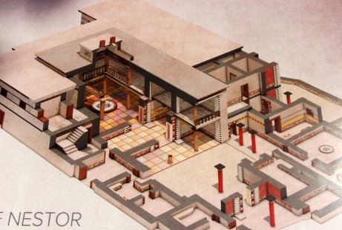
Even earlier than this there was famine in the region. Consider a letter from a Hittite queen in the mid 13th century BC to the Egyptian Pharaoh Ramses II stating, “I have no grain in my lands.” Another letter from a Hittite king to the king of Ugarit stated, on their need for shipments of barley, “It is a matter of life or death.” And sometime later in 1180 BC back in Greece, Pylos, the site of King Nestor’s homeland, the palace was destroyed by fire of great intensity. There is some evidence from Linear B tablets found in the devastation that there were “watchers of the sea,” which may point to concerns from a seaborne invasion of the city, Homer’s “Sandy Pylos,” due its proximity to the coast on the Ionian Sea (see photo.) The palace site was one of the few in the Mycenaean world where no need for massive fortification was felt. Only foundation walls remain now covered by a huge protective metal canopy. A reconstruction of the citadel identifies the colorful interior of the palace which also housed beautiful frescoes. The throne room can be seen in the left center of the photo attached (from Pylos’ archives). Within the existing remains is an interesting remnant, a well preserved bathtub reminiscent of Homer’s ODYSSEY in which he describes Nestor’s daughter caring for and bathing Telemachus, son of Ulysses, on his visit to Pylos. In the background is the palace throne room. In any case, the population of Pylos must have been warned and left before the catastrophic event although being directly on the sea coast there must have been little notice if there were seaborne perpetrators.

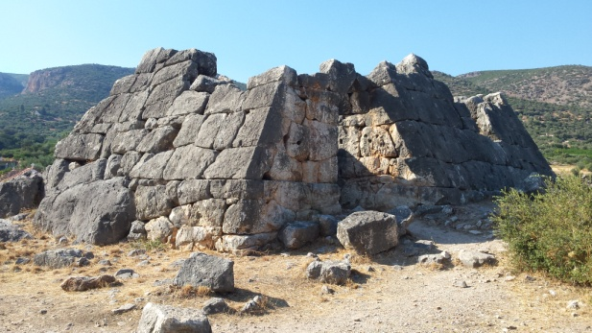
This leads us to the question of what happened to other palaces on the Greek mainland? At Mycenae, the homeland of King Agamemnon, the city was hit by a major earthquake around 1250 BC but recovered only to be destroyed by fire in 1190 BC but like at Pylos it is not known if it was human perpetrators or an act of nature. The palace of Tiryns, nine miles south of Mycenae, was also destroyed in 1190 BC as likely was nearby Argos six miles northwest of Tiryns. (The modern city of Argos completely covers any remains of its Bronze Age past.) Both may have been hit by an earthquake which could have affected Mycenae also. All were in such close proximity to one another, Mycenae the furthest north from the Gulf of Argolikos and Tiryns directly on the coast on the apex of the U-shaped harbor just west of the port city of Nauplio in the eastern Peloponnese. Along that gulf stretching southeast were a series of pyramid-shaped lookout sites (watchers of the sea like at Sandy Pylos) scouring the sea for pirates and other intruders which would have warned and prepared the palaces. In mid August 2019, locals pinpointed the last intact pyramid to me which I found on a strategic prominent not too distant from the harbor. The small pyramid had fortification walls as massive as those of the palace complexes. With warnings of pending intruders it would have been difficult for the palaces, within their massive fortification walls, to be overrun unless guarded by few troops. Very likely it was earthquakes that damaged the sites. Even in ruins, their remains today look very impressive.
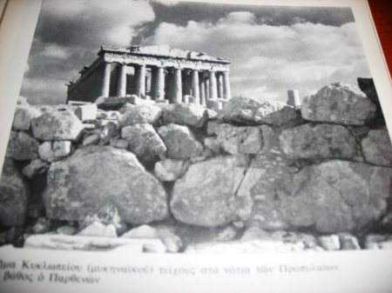
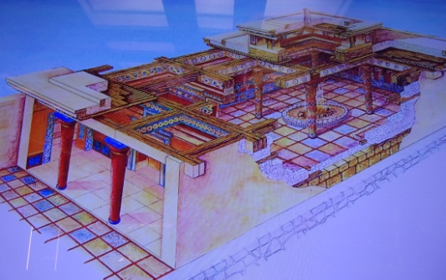
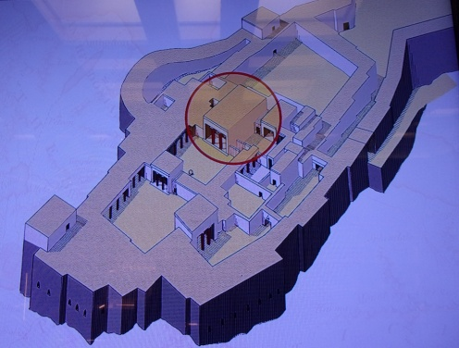
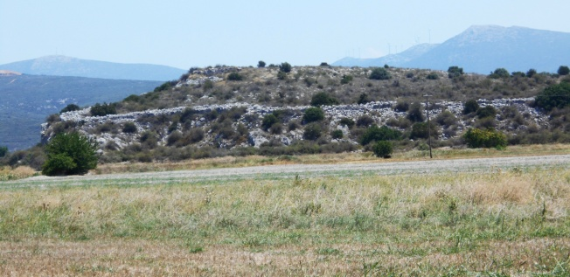
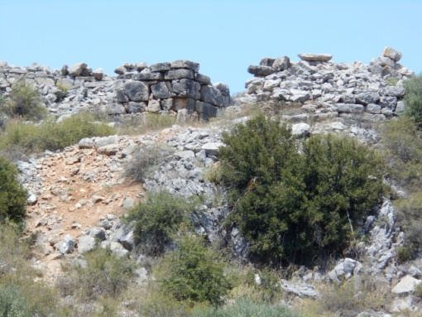
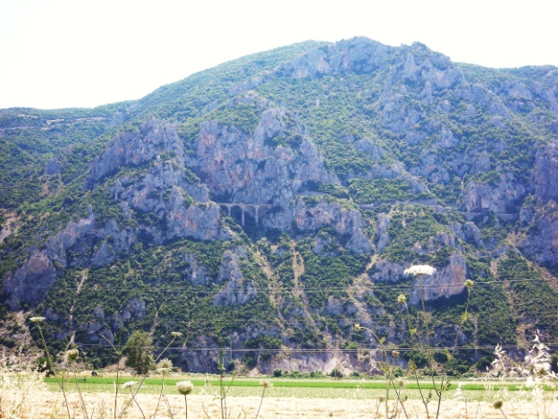
Other destructions occurred on the mainland at that time including Thebes, Orchomenos, and Gla in Boeotia, central Greece, Thebes about 35 miles NW of Athens. There is no apparent evidence that Athens itself was destroyed, less known at that time but buttressed by the port of Pireaus and the towering Acropolis. Some remnants of its cyclopean walls remain just south of the Parthenon. (Photo from the Acropolis Museum archives.) With Thebes built over by its modern metropolitan city, only a one block foundation area in downtown remains of the ancient palace of Kadmeion/Cadmean. It is situated on a ridge, Mt. Helicon, in the central plain of Boeotia. A reconstruction shows the palace complex surrounded with moderately well fortified walls. The megaron, shown in more detail, is reminiscent of the palace complex at Pylos. Photos are from the archives, Archaeological Museum of Thebes. Orchomenos, 15 miles NW of Thebes is today a much smaller city but houses an impressive Mycenaean tholos tomb whose roof has caved in. A well preserved 4th century BC theater is adjacent and to the right of the tomb. Across from the theater is an 8th century AD church which largely covers Orchomenos’ ancient palace site. Both palaces housed beautiful frescoes prevalent throughout many of the Mycenaean citadels. The short street leading to the tomb is named after Heinrich Schliemann who excavated the area beginning in 1881. The massive walls at Gla, 10 miles east and while in ruins, can still be seen. It was not a palace site with a megaron but a very large irregular oblong fortress running east/west whose guardians managed the ingeniously engineered drainage system of the Theban-Orchomenos plain. Of its three entry gates the one shown is from the south. All three sites in Boeotia are inland from the lengthy Gulf of Evoikos some distance from the Aegean Sea. Half way up the gulf at Halkida, where a bridge connects to the Euboian peninsula, sits the port of Aulis where the Greeks gathered their ships before the invasion of Troy and a possible jumping off point for an inland invasion. But a direct sea invasion to central Boeotia would have been difficult though not impossible. Further north at “Rugged Trachis,” five miles south of the city of Lamia, the huge mountain site’s almost impassable terrain located at the western edge of the Maliac Gulf inland from the Aegean Sea, made it impregnable and virtually isolated from destruction. As previously mentioned, Homer identifies warriors from Trachis who fought under Achilles at Troy. Its ruggedness almost precludes site research which this author has attempted. Deep gorges surround the site from the south and west. Several years ago, locals found caves and a rock inscription labeled ΔΑΜΟ half way up the mountain near where the current train tunnel (see photo) runs south to Athens. The site is five miles west of the infamous Battle of Thermopylae (hence the rugged mountains in the surrounding area).

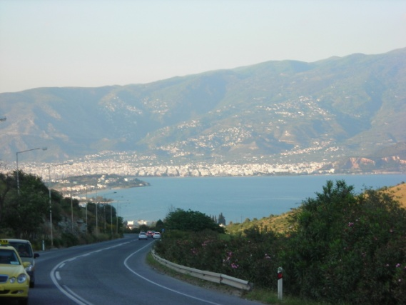
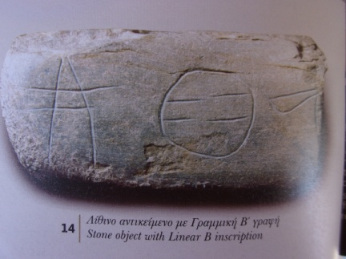
The low lying port city of Volos (of Jason and the Argonauts fame) further north in Thessaly on the Gulf of Pagassitikos and bordered to the north by the Pelion mountain range, was destroyed by fire. Volos itself sits astride an area of seismic activity, remnants of ancient volcanic rocks littering farmlands to the southwest with fissures clearly visible and fine volcanic sand lining beaches nearby at Nea Anchialos. Archaeological evidence shows there was not one but three smaller Mycenaean palace sites at Volos all within a few miles of each other forming an arc around the inner harbor which since has silted up. They were the palaces of Palaia, Dimini, and Pevkalia where Minoan artifacts were also found. At Dimini, several small artifacts with Linear B script have been found (see photo of stone object, like a square weight, from the Archaeological Museum of Volos.) Several Mycenaean tholos tombs have been found surrounding Volos including at Kazanaki where Linear B has been found on the retrieving triangle. Lefkandi on Euboia, the large island peninsula north of Athens which was previously mentioned, was also destroyed. Unknown as to their condition are the palace sites identified by Homer, which as yet have not been discovered, such as Ulysseus’ on Ithaca, or Menelaus’ near Sparta, but two sites, one 8 miles west of Sparta and one 10 miles north may be the location.
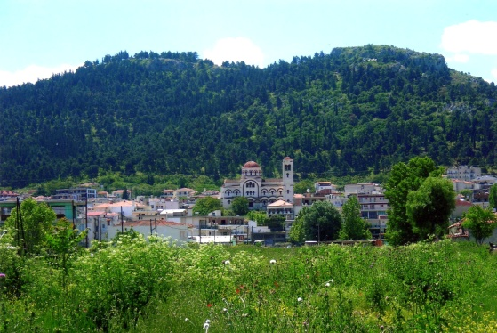
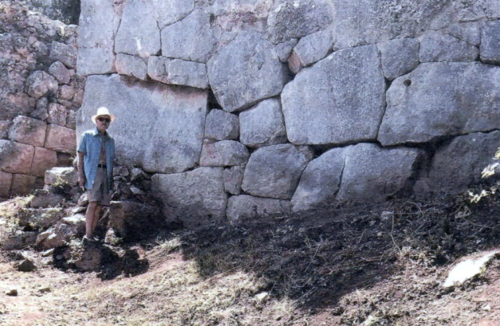
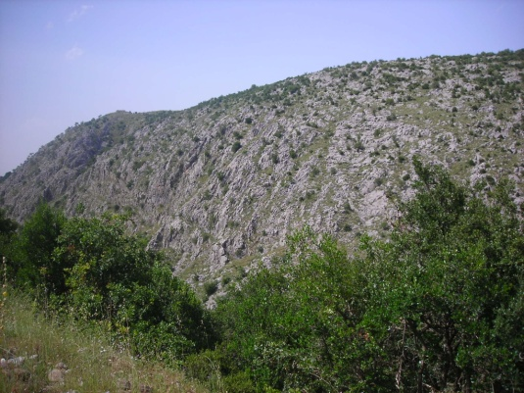
Central and western Thessaly require special attention as to their impact on the Late Bronze Age and even the existence of any Mycenaean presence. Homer identifies eight kingdoms from this province that fought at Troy. While many localities in ancient Thessaliotis and Phthiotis today vie for the title of homeland of Achilles and his father Peleus, which Homer called Phthia, far too many archaeologists, including Ephors of Greece’s regional Ministry of Culture, have viewed this as a myth and with much skepticism. Despite this, extensive research by this author has identified Pharsala, 25 miles west of Volos, as Achilles’ Phthia. It is here in Thessaly and down to Lamia, which in antiquity was the southernmost boundary of Thessaly, where a majority of this author’s two decades in Greece have been spent researching Homer’s kingdoms and the Trojan War and assessing the architectural remains. The saddle shaped mountain, high above to the south and cradling Pharsala, is surrounded by massive fortification walls, including a lower wall in antiquity. It had two main entrance gates, one north and one south. Photo of the north gate is shown with its cyclopean wall. The lower city is entirely built over by modern Pharsala. The mountain fortress would have been a difficult target for invading forces. It should be noted that all such fortress had avenues of escape, typically tunnels exiting far below the fortress walls. This author planned for and promoted the need for systematic research and excavations of the site over these many years. In 2007, funding of 2 million Euros was budgeted by the regional governor through EU’s 5-year budgeting process. With new elections, retirements, and a new Ministry of Culture Ephor, the project never materialized. Later in 2011, with a new mayor, this author prepared a 20 year “Strategic Plan” (see achillesfoundation.org/documents) to move the project forward. Politics, bureaucracy, and a weakened economy intervened. But minor maintenance of the site did take place. Vital excavation work possibly yielding new insights and discoveries could likely be as transformational as “The Ahhiyawa Texts,” to include great economic benefit to the region through international tourism. Twenty five miles further west and past the city of Karditsa is another well fortified site. Identified by Homer as “Rocky Ithomi” whose warriors fought under Podalirus and Machaon, sons of Asclepius from Trikala (ancient Trikki), who served as doctors at Troy. Its massive stone façade, shown in photo from the south, created a formidable defensible position. The fortress walls of Ithomi, like lookout towers and not nearly as extensive as those of Pharsala, are quite distinct from other sites. But as at Pharsala, site surveys show no indication of fiery destruction (as also attested to by a regional Ministry supervisor) although, clearly, excavations would be the determining factor and long overdue for this part of Greece.
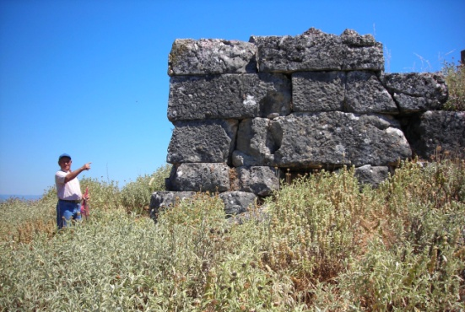
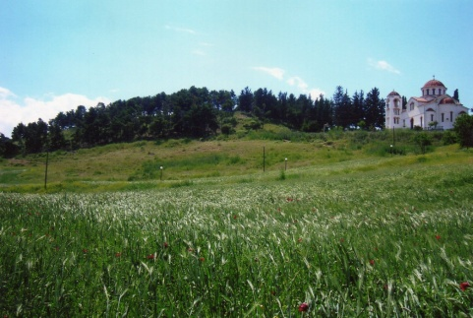
Between Karditsa and Ithomi, at the ancient site of Mitropoli, is a tholos tomb, 27 feet in height and diameter with a 65 foot dromos. While Late Bronze Age excavations in central and western Thessaly are rare, this tomb, closed to the public, has received some attention yielding in 1999 artifacts such as a gold ring and 3 seals, with fine animal engravings, plus an Egyptian scarab etched with a sphinx, all dated to the Mycenaean period. With habitable evidence in the interior of Thessaly existing since 40,000 BC, hominids at the time, and with a subsequent large Neolithic presence, as there was on Crete and the Cyclades, Mycenaeans arriving in Thessaly from the north were certainly not in doubt, though writings by well intentioned archaeologists believed that to be the case (though not so for early German archaeologist Friedrich Stahlin). Homer clearly identified 29 Mycenaean kingdoms in his “Catalogue of Ships.” They included Pherae, present day Velestino, in the kingdom of Eumelus, eight miles west of Volos built on a knoll and susceptible to invasion. Photo shows a Greek Orthodox church built over the site as we know is the case for many ancient sites. And on the southeastern coastline of Thessaly south of Volos down to Lamia several of Homer’s sites can be found. These include Pyrassos, homeland of King Protesilaus, southwest of Volos at Nea Anchialos. And Protesilaus’ palace site of Philaki, as yet not discovered, has been pinpointed by this author to likely be on a knoll just west of Nea Anchialos as also attested to by a former nearby mayor of Almiros, an educated historian, very knowledgeable on his region as I have found many locals throughout Greece to be. The palace walls are barely visible through the vegetation. Heading south then west these are followed by Alos and Alope between which sits the fortress of Larisa Kremaste at the village of Pelasgia, one of four sites where subsequently coins with the head of Achilles have been found (other sites being Larisa, Epirus (province), plus Achilleon just south of Troy). And at Lamia we again arrive at “Rugged Trachis” who warriors along with the last three sites fought with Achilles at Troy.
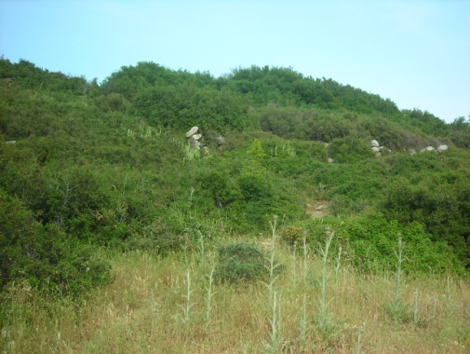
These many sites, a few identified in the beginning of this monograph, support the fact that Homer’s ‘Catalogue of Ships” is clearly historically accurate, reflecting Bronze Age realities. Yet systematic research and excavations, which this author has also discussed with two Ministers of Culture in Athens plus staff in the regions, have not taken place, albeit that permits to foreign countries, only six yearly for the U.S., require adequate funding and university sponsorship plus a lengthy approval process which includes the foreign country’s own archaeological school based in Athens prior to approvals by Greece’s Ministry of Culture. Greece’s “Archaeological School of Athens,” older than the Ministry, often can conduct its own projects. As to susceptibility to seaborne destruction of the above Mycenaean sites, all but Rugged Trachis, Phthia at Pharsala, and Rocky Ithomi are located on generally low lying terrains on or near the coast which would likely have made them targets by the Sea Peoples or other invaders.

In the Aegean, Emborio, on the very southeastern end of the island of Chios, was destroyed by fire. In Anatolia, Miletus, not far from the southeastern Aegean coastline, fell in flames as did the Hittite capital of Hattusa, though being some 150 miles (240 km.) north of the eastern Mediterranean seacoast, the cause there may likely have been the often belligerent Kaska people to their north who may have invaded when the Hittites were most vulnerable.

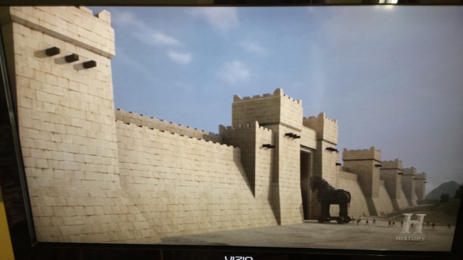
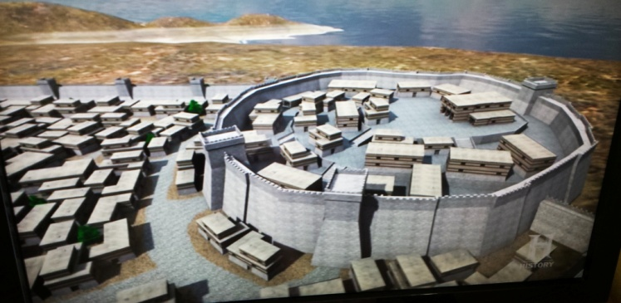
With respect to Wilusa (Troy), at modern Hisarlik, it originally was believed to have come to a fiery end in 1250 BC, but this is now believed to have occurred in 1190 to 1180 BC, the same time period as the palaces in Greece. As Cline also theorized, as has Rose, if the Greeks were away fighting the Trojans at that time, this would have left the palaces on the Greek mainland vulnerable to invaders. That is a possibility but it does not fit the fragmentary stories that have come from the books of the “Epic Cycle,” some which discuss the circumstances of the returning victorious Greeks. While there were mixed receptions of those who found their way back, none were descriptions of returning to destroyed palaces. The city of Troy was virtually impregnable with walls four to five meters (12 to 15 feet) thick and ten meters (30 feet) high. There was also an outer defensive ditch some 200 meters (600 feet) away from and surrounding the palace site creating a dual defense system. In a 2004 BBC TV documentary on Troy, Manfred Korfmann, leader of the team of excavators at Troy from 1988 until his death in 2005 (succeeded by Ernst Pernika), stated, “This magnificent ditch is cut into the rock – so I think we are speaking of a considerable lower city and a lot of effort to fortify it with this ditch.” Clearly with a lower city, Troy was larger than previously believed with a population now estimated to be up to 10,000 people with Korfmann’s colleague, Peter Joblanka, whom with Ernst Pernika I later had been in email contact with, saying the city was ten times larger than previously estimated. (Both photos from Korfmann’s, et al, 2004 presentation for BBC on the History channel.) The ditch was only discovered these last twenty years by remote sensing equipment. The Trojans clearly feared invaders (the Mycenaean Greeks on the top of the list) and were extremely well fortified against this. Homer’s Trojan War of ten years could not have been an exaggeration. The city appeared impregnable. Brian Rose, one of the key excavators at Troy from 1988 until 2012, provides in his book, The Archaeology of Greek and Roman Troy, 2014, interesting background and details on Troy which only an onsite archaeologist (including Korfmann, Pernika, and Joblanka) could provide. In a 2017 interview with me, he stated (as also in his book) that the discovery of this lower ditch was the highlight of the entire excavation. It clearly showed Troy to be much more that a regional outpost and instead an urban center, much coveted for its strategic location and wealth of resources and only four miles south of the mouth of the Dardanelles which leads to the Black Sea.

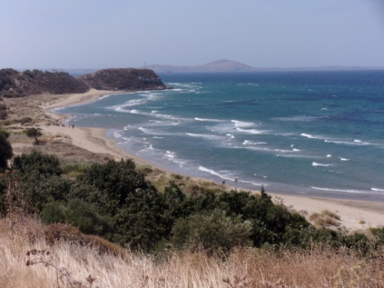
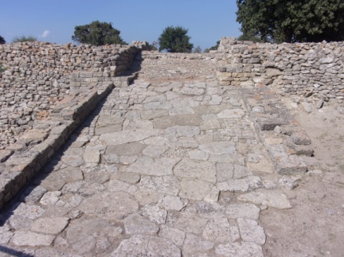
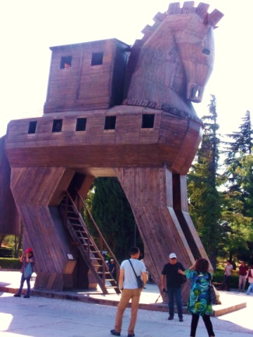
Artifacts discovered at Troy, going back to Schliemann’s excavations beginning in 1871, show clear evidence of Mycenaean presence including earlier finds of the Minoans. Interestingly, very few Hittite artifacts have been discovered though the Hittites tried valiantly to secure Troy as a vassal state for themselves. Today the site draws thousands of tourists from around the world. As they enter, the “Trojan Horse” is there to greet them, and large enough for people to climb into as the Greeks did in successfully sacking Troy. A ramp used to enter Troy from the southwest can be seen today flanked on each side by huge fortification walls. Six miles further southwest is where the Greeks landed there armada of ships and set up their encampment. Photo shows the landing site with the island of Tenedos in the background where Ulysseus and other Greeks built the horse supposedly as “a parting gift to the Trojans.” To the left of the encampment is a 30 foot high mound, known as the “Tumulus of Achilles,” memorializing Homer’s legendary hero of Troy. It is here on September 1, 2019 (I had been to Troy 20 years earlier with one of my five sons) that I drove the 6 miles to the landing site and the tumulus, over rather desolate terrain passing a few villages and a camp ground, to reach the location. Without the help of a local tour guide, whom I have known for some years, it would have been difficult to find. His narration, as we drove, virtually brought to light Homer’s epic story, weaving in the intrigue, the warfare, the emotions, the heroisms and the tragedies. All seemed to come alive. The rolling land also houses a Mycenaean Greek cemetery and in antiquity a town called Achilleon (where, as mentioned earlier, a coin with the head of Achilles was found) built by Greeks migrating to the region some generations after the war. It was here at the tumulus, a hallowed site for ancient Greeks, now void of pilgrimages or people, that I collected earth, placing it into a small urn with the name of Achilles on it, one week later symbolically returning him and the urn back to his homeland in Greece.
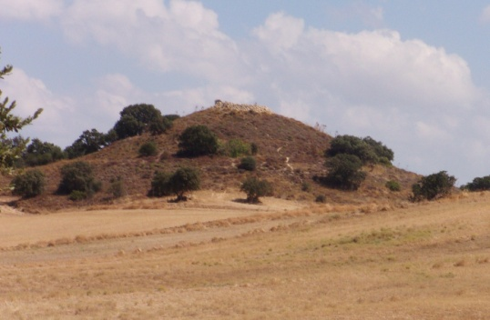
In the end, though, no matter how strong the power grabs were among the great powers of the time, the Greeks, the Trojans, the Hittites, no matter what psychological or economic forces drove these kings to demand allegiance and respect for their power, they lost it all. Dead bodies were found among the ruins of the Troy of 1180 BC as well as arrow heads in the walls, and a fiery destruction. No doubt, continued battles at Troy as well as natural events had direct impact on its sustainability of which the Greeks played a very large part. While the tradition of Homer’s Trojan War remains strong and has some validity as to its historicity, “The Ahhiyawan Texts” themselves, very informative and intriguing, do not provide clear, direct evidence that the Greeks did fight the Trojans at Troy. On the other hand, Joachim Latacz in his book Troy and Homer, 2004, states, “It would not be surprising if, in the near future, the outcome states: Homer is to be taken seriously.”

But subsequent to the destruction of Troy and other sites in Anatolia, at Mycenae and other sites in Greece and elsewhere, the “movement’ and “migrations” of people throughout the eastern Mediterranean during the 12th century BC and into the “Iron Age” that followed down to the 9th century, brought with it a “Dark Age,” at least as far as the demise of the central administration of the palaces and its ruling elite is concerned. Writing ceased, as expected, since no longer were scribes available who promoted the literary tradition of the palaces and its top down bureaucracy. There were areas that flourished although within a more modest cultural environment and smaller settlements with some rebuilding of areas devastated and others continuing, like farmers in Thessaly, Greece’s main breadbasket. Except at Volos on the coast, no evidence shows fiery destruction of the fortresses surrounding the interior broad plain of Thessaly, whether at Pharsala, Pherae, Ithomi, or Trikala further west, but, as previously stated, excavations are needed to prove this conclusively. At Pharsala, with its massive hilltop fortress, a 10th century cemetery was discovered in 2007 on the city’s outskirts during a road building project. It was composed of cist graves, two feet below the surface, and very small chamber tombs. Ialoysos on Rhodes was not destroyed and may have received refugees from other Mycenaean regions as did the island of Cyprus. Eventually wholesale movements of mainland Greeks took place settling throughout western Anatolia, the Black Sea, North Africa, later Sicily and beyond. Though Egypt did not sub come to the devastation, within a century it lost much of its prior glory, as may be expected from the state of affairs throughout the eastern Mediterranean. For this author and for many others, the words of Wolf-Dietrich Niemeier ring clear on the challenges faced in better understanding our past: “Still, the reconstruction of the earliest Greek history remains the most important task of modern historical science.” With so little that has been discovered, the challenges remain.

Final Word on the Trojan War

In 1430 BC there was a war near the vicinity of Troy. The Greeks were the attackers and the Hittites the defenders, the Hittites traveling 450 miles to their west to dislodge the invading Greeks from the vassal states under Hittite authority. The Greeks were defeated twice by the Hittites. Twenty-two vassal states of the Hittites also rebelled against their Hittite rulers but were crushed. The Greeks continued their hostility but by the late 14th century BC they reluctantly sought peace. Between 1267 and 1237 BC, the Greeks and the Hittites again fought and this time specifically at Wilusa (Troy). It ended in a stalemate. Peace ensued. But this time the Hittites were the aggressors. Though there was peace, the Greeks were no doubt angered. They, throughout most of the 220 years covered by this dialogue from and between the Greek and Hittite kings, were themselves the aggressors supporting vassal states to rebel against the Hittites and eventually ruled territory at Milawata (Miletus). The warlike character of the Greeks never stopped. Archaeological evidence shows there was destruction at Troy in 1300 BC, apparently from an earthquake. Evidence reveals another destruction in 1180 BC, but this time a fiery one as described above. This was a period of invasion and destruction throughout the eastern Mediterranean. Communication among the Greeks and the Hittites ceased some thirty years before this. There is no evidence of who destroyed Troy at that time. Clearly there was a war at Troy around 1250 BC in which the Greeks fought, so yes, there is truth in a Trojan War, and truth in several parts of Homer’s Iliad. Tradition supports him but more evidence is needed if we are to describe “Homer’s Trojan War” as a historical fact.

While at this time it is clear that Homer’s war is itself not a “historical fact,” we can say from the Ahhiyawa texts that it is based on “historical precedence.” It no doubt was derived from actual events which we ourselves have witnessed in the dialogue between the various kings of two great powers. These “Voices from the Past” show clear evidence of a Trojan War, though as yet not necessarily Homer’s war. But from the perspective of “historical tradition,” which even today exists in many areas among the people of Greece, the words as stated by this author in a 2011, thirty-five page monograph ring clear, “The Trojan War was real and Homer’s Iliad describes real historical events as over 2000 years ago the Greeks themselves attested to.” He no doubt enriched these events, arguably valuing his heritage, putting them and the players into a reasonable context as believed and understood by him and the people of his time. He brought his players to life giving them voices and to the events by heroics, passion, and intrigue all enhanced by his fire and poetic beauty. So clearly, while specific historical reality remains in question, historical precedence is there. It can no longer be said that Homer’s Trojan War is a myth or legend, an imaginary story from imaginary places and an imaginary period.

Homer, born in western Anatolia, on the Aegean coast at Smyrna, was privy to the stories handed down from generation to generation over some 400 years and more, stories of war, hostilities, invasions, and intrigue in a war-torn land controlled by ruling elites and their armies, stories which stirred his imagination and interest in the ancient past (as I and many are today). From the people he met in his early travels, not only in Anatolia but also on mainland Greece and the islands, he like Strabo and Pausanias, many centuries later, recorded in his memory and with notes (writing had finally come to Greece) discussions he had with people and the sites he saw throughout these lands. Names recalled to him from distant memory likely included Agamemnon (Kagamuna), Atreus (Attarasiya), Alexander (Alaksandu), Menelaus (Tawagalawa), and Achaians (Ahhiyawans), all discussed below. It is unlikely, as other authors stated, though not impossible, that it was the Greeks who in 1180 BC captured and destroyed Troy at a time when, a decade or two before and after, most of the citadels of the eastern Mediterranean suffered destruction. It is reasonable to believe that Homer may have taken the collective memory of 220 years of history from the remote past and distilled them into a 10-year war, 51 days of which he described in the ILIAD with portions in the ODYSSEY. He may have been motivated by thoughts of memorializing his forefathers (as many cultures do today including modern Greeks), by the wonder of and insights gained from his earlier travels, by economic rewards from royalty or barons he entertained, and by his collegial group of professional bards which led him to recite, time and time again, and finally have recorded, about 750 BC, his epic works, works which probably received their final editing at the Alexandrian Library in Egypt during the Hellenistic period some 500 years later. It is possible that one major war among the many stood out in the memory of the people, a war which likely occurred 1237 to 1209 BC. With this background, his intellect, and his blindness later in life, which he likely was, his mind and his senses were sharpened giving him greater insight and visual acuity and a keen sense of purpose, never thinking that his works would live on for eternity. (Retrospectively, subsequent to my above conclusion, in early 2020 I conducted further research to assess any concurrence by scholars with my own thoughts. Interestingly, Trevor Bryce, one of the three authors of “The Ahhiyawa Texts,” stated in a 2004 BBC TV interview (previously cited in Manfred Korfmann’s discussion of Troy); “I believe that these conflicts (at Troy) were distilled into a tradition of a single war lasting ten years.” Very surprising but powerful corroboration of the analysis on Homer and the Iliad made in this monograph.)

The kingdom of the Hittites was gone but as Homer traveled throughout western Anatolia, riddled with mountains, valleys, plains and hilltops, and bordered by the blue Aegean Sea and inhabited now for some centuries by large numbers of mainland Greeks, he saw Troy and its massive fortress as the principal site of the events, identifying the allies of the Trojans and the kingdoms of the Greeks led by the son of Atreus, molding them into an epic story the world will forever embrace. It is a monumental piece of literature, “The Greatest War Story Ever Told.”
_________________
Note: At a conference in Greece in 2014 sponsored by this author and colleagues (councilofachilles.org), historical tradition on Homer was found to be very strong. In an anonymous preconference questionnaire, of the 75 people who responded to the question, “Do you believe that the Trojan War and its Greek hero Achilles were real or a myth?,” on a 5-point scale, 71 of the 75 people (95 percent) overwhelmingly believed that the Trojan War and Achilles were real and not a myth.
Of Special Note: Oldest Recorded Greek Names

One of the many enlightenments provided by the Hittite tablets in “The Ahhiyawa Texts” is the identification of possibly the oldest documented evidence of actual named Greek persons. They are as follows:

- 1435 BC – King Kagamuna, a king from Greece, likely Agamemnon, (K)Agamemnon.*
- 1400 BC – King Attarissiya, a king from Greece, likely King Atreus, father of Agamemnon.
- 1290 BC – Alaksandu, King of Troy, likely Alexander, Paris, who abducted Homer’s Helen. (Alaksandu likely born from a Trojan woman and a Greek father).
- 1250 BC – Tawagalawa, brother of a Greek king - Agamemnon’s brother Menelaus?
- Ahhiyawa (Achiyawa) – The Hittite name for the Greeks, Homer’s Achaians.

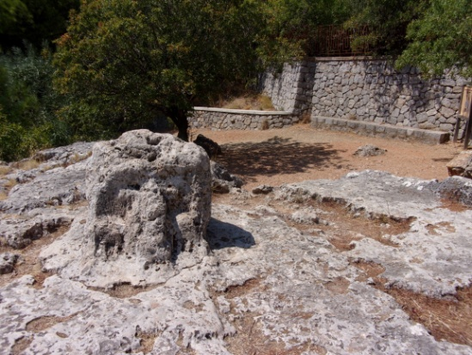
Homer was likely born in the Anatolian town of Smyrna (modern day Izmir, Turkey) on the western Aegean coast and lived his life likely on the Greek island of Chios, a stone’s throw from coastal Anatolia. At Daskalopetra (teachers’ rock) on Chios, just north of the modern capital city, is a small stone chair found on a rock ledge near and just above the coast which legend has it the Homeridae, who carried on his tradition, recited his stories and maintained the site in honor of Homer. It was here on August 28, 2019 I was driving to locate the site listening to music on the rental car radio, haunting melodies coming from the Anatolian coastline immediately to the east across the strait. As I walked attempting to locate the site, a young lady brought me to it. She fondly related how in her youth her teacher would bring students to this location almost as a pilgrimage. Her sincerity and vivid imagery of those school trips highlight the strong tradition held on Chios for Homer. During his travels in western Anatolia and the Greek lands in the 8th century BC, some 400 years after the fall of the empires, local residents including many descendants of the fighters provided Homer with stories and their recollection of names handed down through the generations that related to the wars at Troy and the western coast of Anatolia. Other names no doubt were Homer’s hero, Achilles, Ajax, cousin of Achilles, Nestor, oldest of the Greek kings to fight at Troy, Ulysses, and many more. Not having a written language until nearly Homer’s time, the Greeks could not provide a literary record that could be preserved through time. Hence, the collective memory, however faulty, became the method for reconstructing the past although it is possible Luwian, Phrygian and Phoenician writing/script may also have been available but lost through time. Homer’s intellect and ingenious story-telling, based on this historical precedence, wove a picture of that past, one that has captured the imagination of and has inspired people worldwide.

- During a 3-month research trip to Greece plus Turkey summer of 2019, this author took a periodic random survey of Greeks – scholars, museum officials, lay people -- asking their impression of the name Kagamuna as possibly related to the Trojan War. With N=25, without hesitation each person’s immediate response was “Agamemnon.”

ADDENDUM September 2018

Subsequent to the writing of this monograph, an article in the journal of “Mediterranean Archaeology and Archaeometry” came to light which provides new evidence for the period of Homer’s Trojan War. Written by six professors from the Universities of Patras and Athens in Greece in the Departments of Geology, Physics, Astrophysics, and Astronomy, the article studies the solar eclipses described in the ILIAD and the ODYSSEY. From this author’s perspective these eclipses, if valid, are a little known and overlooked part of the entire epic stories. The writers state, “We examined the solar eclipses within the time span of 1400-1130 BC and we found that only the annular solar eclipse of 6th June 1218 BC observable in Troy with significant obstruction 75.2% fits fully with the Homeric descriptions.” They base this on Homer’s apparent descriptions of solar eclipses occurring during the death of Achilles’ childhood friend and cousin, Patroclus, at the hands of Hector and the fight to retrieve his body (Books 16 and 17 of the ILIAD) and the other on the return of Odysseus to Ithaca they dated 30th October 1207 BC (Book 13 of the ODYSSEY). The basis of the writers’ analysis was the “Canon of Solar Eclipses Data Base” from NASA (Nat’l Aeronautical and Space Administration).

In Book 2 of the ILIAD, Odysseus states “It is now nine long years that we have been kept here” (in Troy). From this and other such references to a 10 year war, the writers state that the war began in 1228 BC and concluded during the summer of 1218 BC, the last 51 days of the war.

The evidence above providing a timeline of 1228 to 1218 BC for Homer’s Trojan War corroborates the analysis of the Ahhiyawa texts provided by this author. For example, in the Tawagalawa Letter during the reign of King Hattusili III, 1267 to 1237 BC, the war fought at Troy between the Greeks and the Hittites greatly angered the Greeks. The war, the Hittites the aggressors, brought a subsequent response from the Greeks, “You have used force against me.” The Hittite king responded “But I was still young.” From the texts, I concluded, “A large measure of mutual trust may have been shattered,” further stating “Revenge may finally be on the mind of the Greeks.” Also, “The Greeks may be harboring resentment against the hostile offenses that H III confessed to.” I further stated the Greeks “may likely have developed a plan or strategy of their own to rectify the hostile action of the Hittites – if not immediate retaliation then possibly in the near future when the Hittite kingdom may be more vulnerable.” That vulnerability came during 1237 to 1209 BC a period of decline in the eastern Mediterranean. The Hittites had a difficult time maintaining control of their vassal states in western Anatolia. The Assyrians defeated the Hittites in 1237 BC, the Babylonians in 1225 BC, and again the Hittites fell to the Assyrians in 1209 BC this preceded by likely internal strife and civil unrest in the Hittite capital and activities by the belligerent Kaska kingdom to the north of the Hittites. Likely, then, the Greeks in 1228 BC executed their “Revenge Strategy” waging war against the Trojans in an area the Greeks strove to secure for generations. While according to astronomical research Homer may at last be vindicated, it is clear that from the Ahhiyawa texts there is considerable precedence for the historical reality of Homer’s Trojan War. This eclipse analysis was disputed to me in a brief meeting with Eric Cline at GWU in late 2018 also disputing NASA’s data. At a subsequent meeting by this author at Athens University June 2019 with two of the article’s authors, they hoped Cline would reconsider but they remained firm on their analysis.

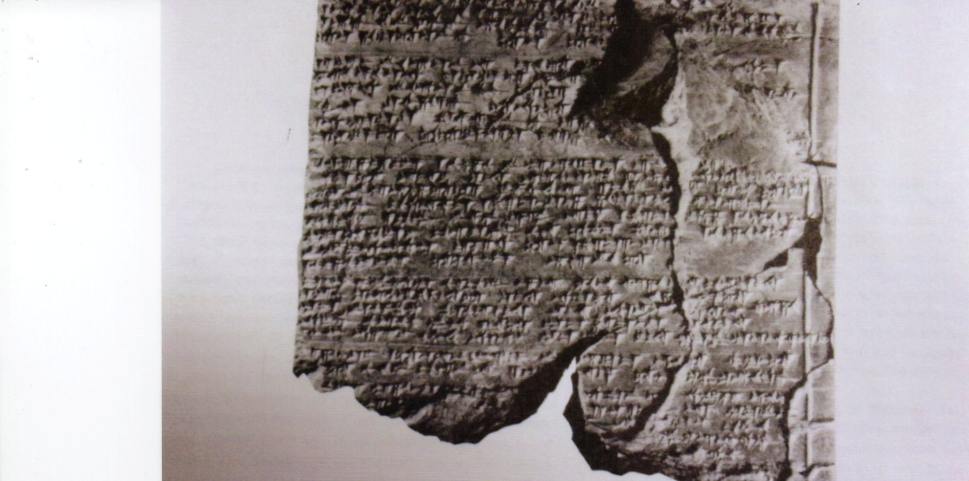

Cuneiform Writing
(Oriental Institute Museum, University of Chicago)

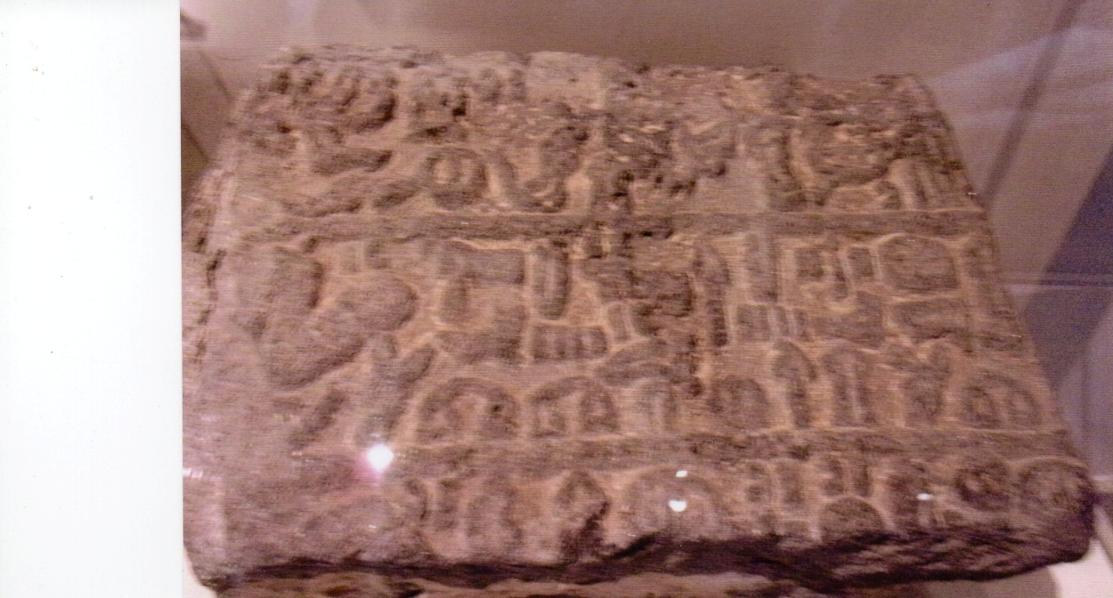

Hieroglyphics
(Oriental Institute Museum, University of Chicago)
The Message, The Messenger, and The Method

This writing has discussed several letters sent by Greek and Hittite kings of the Late Bronze Age but not the method of how the letters were prepared and how they were transmitted to their intended receivers. So how did the kings’ messages get to their recipients? How was the writing done? Who were the messengers? What was the final method for transmitting them to their intended recipients? Harry Hoffner Jr.’s publication, Letters from the Hittite Kingdom, 2009, provides some interesting background.

It was the scribes who were the critical component. They came from the upper class of the kingdom, the elite of the royal court, and sometimes even a crown prince. There was a “Scribe School” specifically for learning how to do the job. Not only did the scribe reside at the court but when the king traveled, such as on a military campaign, the scribe would be in attendance.
The languages and scripts used were cuneiform, Akkadian, and hieroglyphics. Only the scribes of the kingdom knew them and how to use them. The upper echelon of the kingdom and even the king typically could not write. For the average person Luwian was the demotic, spoken language and written in hieroglyphic script. Cuneiform, on the other hand, was used for diplomatic and administrative writing, Akkadian for international, diplomatic writing, and hieroglyphics were usually chiseled onto stone for all to see such as a huge rock on a prominent road. With no written language of their own, the Greeks at that time relied on scribes, fluent in Greek and Hittite and residing at their court, to write their message.

The tablets for cuneiform were irregular in size and rather small no larger than 3X4 inches (7.5 cm. X 10 cm.) and many times smaller. A scribe would take a freshly prepared clay tablet and with a reed stylus would record the words of the king. “Once the tablet was inscribed, the scribe would read it over to the author, making whatever corrections necessary, and then enclose it in an envelope which he would seal with the sender’s seal.” For writing in Akkadian (see front cover), a similar process was followed but a metal stylus would be used. The messenger, the courier, was the next step in the process. He would be valued for his stamina for the letter was often carried by foot over long distances and often rough terrain through a system of relay runners (horses were as yet not domesticated for riding.) Road projects in those days were the responsibility of the local ruler. “At times international messengers would join merchant caravans in order to enjoy a measure of security when passing through dangerous regions.” If a king had an important message that he feared may be intercepted, that message was transmitted orally with trusted messengers. The receiver would likely test the messenger to assess his trustworthiness.

For storage in their “library,” usually in main temples, “the scribes kept the tablets in a certain order on wooden shelves.” Lists were prepared showing storage rooms with “listed tablets in their order on the shelves.” The value of the letters was that the majority were contemporary with the events they relate. They confirm the historical reality, the historicity, of the events as described and interpreted by their authors. Their historical significance is invaluable and adds immensely to our understanding of the ancient world particularly in our attempts to assess myth or legend against reality.

Bibliography

- Allen, Thomas W., The Homeric Catalogue of Ships, Oxford: Clarendon Press, 1921.
- Apollonius of Rhodes, Jason and the Golden Fleece, ed. and trans. Richard Hunter. New York: Oxford University Press, 1998.
- Bahn, Paul G., ed., Cambridge Illustrated History of Archaeology, Cambridge University Press, Cambridge, England, 1996.
- BBC, “Science and Nature – The Truth of Troy,” Manford Korfmann, Peter Joblanka, Trevor Bryce, Eric Cline , et al, www.bbc.uk/science/horizon/2004/troy.
- Beckman, Gary M., Trevor R. Bryce, and Eric H. Cline, The Ahhiyawa Texts, Society of Biblical Literature, Atlanta, 2011.
- Boardman, John, The Greeks Overseas: Their Colonies and Trade, Thames and Hudson, London, 1980.
- Brianas, James and Spyro Baikousis, “Birthplace of Hellas: The Ancient Site in Greece Where the Greek Nation Received its Name,” The Ahepan, (Winter 2018): 12-16.
- _______, and Achilles Goundopoulos, “Homer’s Achilles: Land of the Myrmidons in Thessaly,” The Ahepan, (Summer 2006): 18-21.
- _______, “Update on Achilles Excavation of Homer’s Phthia: A Vision for Historic and Economic Development,” The Ahepan, (Summer 2007): 20-21.
- _______, “Resurrection of Achilles Homeland and Capital City Phthia: What Historical Research Reveals,” A monograph, 2011.
- Cline, Diane Harris, The Greeks: An Illustrated History, National Geographic, Washington, DC, 2017.
- Cline, Eric H., 1177 B,C.: The Year Civilization Collapsed, Princeton University Press, Princeton and Oxford, 2014.
- Dindorfius, Guilielmus, ed., Scholia Graeca in Homeri Odysseam Ex Codicibus Aucta et Emendata, Oxonii: E Typograheo Academico, 1855.
- Edwards, Mark W., Homer: Poet of the Iliad, The Johns Hopkins University Press, Baltimore and London, 1987.
- Finley, M. I., Early Greece: The Bronze and Archaic Ages, W. W. Norton & Company, New York and London, 1981.
- Hoffner, Jr., Harry A., Letters from the Hittite Kingdom, Society of Biblical Literature, Atlanta, 2009.
- Holst, Sanford, Phoenician Secrets: Exploring the Ancient Mediterranean, Santorini Books, Los Angeles, 2011.
- Homer, The Iliad, trans. Robert Fagles, Penguin Books, New York, 1990.
- Intzesiloglou, Babis G., “A Gold Signet Ring, Three Seal Stones and a Scarab From the Mycenaean Tomb at Georgiko, Western Thessaly (Greece)”, proceedings of a conference in Germany, “Corpus Der Minoischen Und Mykenischen Siegel,” 9 -12 October 2008, published 2010, 239-247.
- Κατακουτα, Στελλα, Γιωργιος Τουφεξης, ”Θεσσαλια: Δεκαπεντε Χρονια Αρχαι−ολογικης Ερευνας, 1975−1990, Conference, Lyon, France (17-22 April 1990): 188-200.
- Latacz, Joachim, Troy and Homer: Towards a Solution of an Old Mystery, Oxford University Press, Oxford, England , 2004.
- Macdonald, Colin E., Erik Hallager, and Wolf-Dietrich Niemeier, eds, The Minoans in Central, Eastern, and Northern Aegean – New Evidence, Acts of a Minoan Seminar 22-23 January 2005, Monographs of the Danish Institute at Athens, Vol. 8, published 2009.
- Morkot, Robert, Historical Atlas of Ancient Greece, Penguin Books, London, 1996.
- Niemeier, Wolf-Dietrich. “Mycenaeans and Hittites at War in Western Asia Minor,” Aegeaum 19, PI XV. From Annales d’Archeologie Egeenne de l’University de Liege et UT-OSAP (14-17 avril 1998).
- Paramarinopoulos, S. et al, “A New Astronomical Dating of the Trojan War’s End,” Journal of Mediterranean Archaeology and Archaeometry, Vol. 14, No. 1, 2014, 93-102.
- Pausanias, Guide to Greece 1: Southern Greece, ed. and trans. Peter Levi, London: Penguin Books, 1979.
- ________, Guide to Greece 2: Central Greece, ed. and trans. Peter Levi, London: Penguin Books, 1979.
- Quinn, Josephine, In Search of the Phoenicians, Princeton University Press, Princeton, N.J., 2018.
- Rose, Charles Brian, The Archaeology of Greek and Roman Troy, Cambridge University Press, Cambridge, England, 2014.
- Ruden, Constance von and Johannes Jungfleisch, “Incorporating the Other: A Transcultural Perspective on some Wall Painting Fragments from Hattusha,” proceedings from a conference, Internationaler Workshop, Istanbul 23-24 Mai 2014, pp 60-83.
- Runnels, Curtis and Priscilla M. Murray, Greece Before History, Stanford, CA, Stanford University Press, 2001.
- Sandars, N. K., The Sea Peoples: Warriors of the Ancient Mediterranean, Thames and Hudson, Revised Edition, 1985.
- Stahlin, Friedrich, Η Αρχαια Θεσσαλιοτις, Θεσσαλονικη: Εκδοτικος Οικος. Greek translation from the German, 2002 (1924).
- Schofield, Louise, The Mycenaeans, The British Museum Press, London, 2007.
- Snodgrass, A. M., Editor, Archaeology and the Emergence of Greece, Cornell University Press, Ithaca, NY, 2006.
- Vermeule, Emily, Greece in the Bronze Age, The University of Chicago Press, Chicago and London, 1972.
- Wace, Allen J. B. and Frank H. Stubbings, A Companion to Homer, London: MacMillan & Co. Ltd., 1962.
- _____, and M. S. Thompson, Prehistory Thessaly, Campbridge, UK: The University Press, 1912.
- West, Martin, ed. and trans, Greek Epic Fragments, Harvard University Press, Cambridge, 2003.
- Westlake, H. D., Thessaly in the Fourth Century B,C., Chicago: Ares Publishers, Inc., 1935.

About the Author
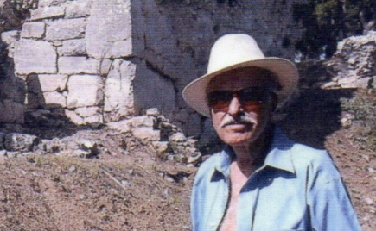
James Brianas is President of “The Achilles Foundation,” a nonprofit organization researching the historical tradition and historicity of Achilles, hero of Homer’s Trojan War, and advancing the history and the archaeology of Greece and his homeland in the province of Thessaly, ancestral homeland of his parents who emigrated to the United States in the early 20th century. Educated in Architecture, Psychology, and Government and Corporate Management and Leadership at the University of Florida, George Washington University, and in England, he worked in Federal government agencies in Washington, DC as a Research Analyst and on the faculty of universities in metropolitan Washington, including the University of Maryland University College and Florida Institute of Technology specializing in Organizational Behavior and International Management and Leadership, engaging in the international milieu of the nation’s capital. He also served overseas in the Middle East for five years with a multinational corporation, traveled throughout Europe, the Near and Middle East including Turkey, Cyprus, Jordan, Saudi Arabia, and in Egypt and Morocco, and a military tour in Korea and Japan.

His visit to Troy in 1999 peaked his interest in Greek history, of which he was indoctrinated as a child growing up in the ethnic, mill town communities of southern New Hampshire, and his interest in the archaeology of his own ancestral homeland in Thessaly. Numerous visits to Greece (and Turkey) and onsite research from valleys and hilltops to local villagers and towns people, relatives, city officials, and Ministry of Culture archaeologists and other scholars provided enormous insight and knowledge of the people, the places, and the traditions that sustain and drive a culture with such a rich history. Although a Research Analyst and Professor his lack of early archaeological training was augmented by extensive library and other literary research including the Harvard Center for Hellenic Studies in Washington. DC and Blegen Library in Athens, Greece, meetings with noted archaeologists (and Hittitologists) as well as his own library of archaeological texts. His sponsorship, through the “Achilles Foundation” in cooperation with the regional “Council of Achilles,” of two conferences in Greece in 2014 and 2015 on the controversies surrounding Achilles plus the site of the ancient city of Hellas where Greece derived its name, provided increased support and awareness for archaeological activities important to the region and key sites prime for systematic research and excavation and, of equal importance, the potential economic benefits of this to the people of the local communities. Knowledge gained from “The Ahhiyawa Texts” comprise a vital part of these efforts and a better understanding of early Greek history and particularly controversies of the Late Bronze Age and events of that period. The hope is for the general public, and with a translation distributed to colleagues and friends in Greece during a seminar on the “Texts” presented by him and his colleagues in 2019, this monograph will add to that understanding.

While many glory in the fascination of ancient Greek history others disparagingly dismiss as myth and legend much of its past. But we know that this earth has yielded very little of what it harbors. It is encouraging to see that as every year passes new discoveries are made that are rewriting history the world over.

Email: jamesgbrianas@gmail.com. Phone: 386-453-8450

